An Improved Energy Management Strategy for a DC Microgrid including Electric Vehicle Fast Charging Stations

Abstract
The number of electric vehicles (EVs) on the road is expected to continue to increase during the next decades due to various factors such as the rapid progress in EV technology and decreasing battery prices. The prolonged battery charging process, which is one of the main problems that affects the increased EV penetration, makes the fast charging units more attractive and efficient option for the charging stations. In this study, a control strategy for a DC microgrid including electric vehicle fast charging station (EVFCS) and distributed generation units is presented to examine the impacts of EVFCS on the grid as well as their potential contributions to the system operation in the case of considering the vehicle-to-grid (V2G) technology. It is especially aimed to mitigate the voltage sag and swell problems by using the EV battery as a DC source of a distribution static compensator (D-STATCOM) device. Simulation studies in MATLAB Simulink/SimPower systems show that considerable improvements can be achieved from the perspective of distribution system operation such as improved voltage quality and from the perspective of end users such as decreased charging durations.
Keywords—Electric vehicles, fast charging stations, microgrid, distributed generation, V2G.

- INTRODUCTION
Recent technological advances and anticipated economic and environmental benefits have significantly increased the number of electric vehicles (EVs) on the road at the last decade. According to Energy Outlook and International Energy Agency (IEA), the EV number is expected to reach 250 million by 2030 [1]. One of the main barriers that hinders the full potential of increased EV penetration is the limited charging rate of EV charging units, which generally causes long charging periods. For instance, traditional EV charging units, namely, level 1 and level 2 chargers can fully charge a depleted battery between four and sixteen hours, which is only feasible for overnight or charging at work [2]. Therefore, the level-3 DC EV fast charging units, which have the capability of charging an EV in less than 30 minutes come into prominence recently; however, the high charging power value of these units brings additional burden on the power grids [3].
Besides, these units might still contribute to the carbon emission indirectly as a large portion of the energy requirement of EV charging stations (EVCS) is supplied by power grids. Also, the nonlinear characteristics of EVCSs affect the power quality by causing voltage fluctuations and power losses [4]. These problems are especially of great importance for the residential level-3 DC EV fast charging units as they are connected to the distribution networks directly.
In order to alleviate the negative effects of the abovementioned problems, the electric vehicle fast charging stations (EVFCSs) have been recently used in microgrid environments coupled with distributed generation. García Triviño et al. [5] proposed a decentralized control method for a grid-connected microgrid consisting of two EVFCSs, photovoltaic (PV) panels and an energy storage system (ESS) to maintain the medium voltage DC bus voltage and the state of-charge (SOC) of ESS within predefined thresholds. A similar DC microgrid structure including EVCSs with slow and fast charging modes, a PV system and an electrochemical storage system was considered in [6] and an EVCS power management strategy based on power limitation and driver choices was proposed. The potential of integrating EVFCSs and a PV system in a microgrid architecture was investigated in [7] in terms of economic benefits. Another PV- and ESS integrated DC microgrid was considered by Wang et al. [8] and a decentralized primary control method based on the adaptive droop control of the ESS was developed for less frequent grid connection and higher PV penetrations. Wang et al. presented a model-based continuous differentiable charging approach for EVCSs in microgrids with the aim of reducing the charging time without scarifying battery health [9]. Another DC microgrid structure including PV rooftops, ESSs and EVFCSs was considered in [10] with the targeted innovations for both system manager and end-user.
As can be seen from the studies mentioned above, in the case of using EVFCSs in a microgrid environment, which has the capability of effectively managing energy exchanges with the power grid and among its components, the energy requirements of the EVFCSs can be provided with less power losses and higher economic benefits while also limiting the peak-to-average load ratio. In addition to these studies mainly aiming to decrease the impacts of EVFCSs on the grid, the use of the available energy in the batteries of EVs connected to EVFCSs, which is called vehicle-to-grid (V2G) technology, has been also investigated in several recent studies for the purpose of supporting the distribution system operation. Ahmad et al. [11] presented an energy management method based on switching mechanism among trading markets for public EVCSs integrated with a microgrid and dealt with the balancing of total load demand and generated power by also considering V2G. An EVCS equipped with a PV array, an ESS and a diesel generator was used in [12] with the objective of providing the required charging energy in both islanded and grid-connected modes. Rodrigues et al. [13] proposed a holistic V2G coordinated approach for EVs in unbalanced smart microgrid environments in order to support the network by using the available stored energy in EVs. Salvatti et al. [14] presented an energy management approach for microgrids containing an EV parking lot, PV arrays and dynamic loads, in which PV production and load demand predictions are used to optimize the EVs’ charging and discharging profiles. Another control and scheduling approach for charging and discharging of EVs was developed in [15] to enable the integration of a high number of EVs in a microgrid. For the purpose of protecting the EV batteries and saving their lifetime during the grid connections, a V2G scheduling approach based on frequency control was proposed in [16].
As seen from the literature reviewed above, several studies have considered the use of V2G technology for supporting the grid; however, none of these studies investigated the possibility of using EV battery in V2G mode as a DC voltage source in a distribution static compensator (D-STATCOM) system to further improve power quality. Motivated by this fact and by the results presented in the literature showing that EVs can considerably contribute to the flexibility of distribution systems in microgrid environments, and that EVFCSs have been gaining growing interest in the recent years, a low-voltage DC microgrid including level-3 EVFCS, solar PV arrays and a diesel generator as distributed generation units is considered in this study. A control strategy based on adaptively controlling the converters of distributed generation units and EVFCSs is proposed by also considering V2G technology for EVFCSs with the objectives of providing flexibility in the distribution system operation, decreasing the EV charging times and mitigating the impacts of voltage sag and swell in the distributed grid.
The contributions of the study are twofold:
1) A control strategy for a low-voltage DC microgrid including distributed generation units and level-3 EVFCS with V2G technology is considered.
2) The idea of using a battery storage system as a DC source of a D-STATCOM device, which was proven as an effective approach in the literature [17], [18], is extended for the batteries of EVs for the first time in the literature.
The rest of this paper is organized as follows: Section II describes the system structure considered in the study and Section III elucidates the proposed control strategy. Section IV describes the EV battery-integrated D-STATCOM. The case studies and simulation results are presented in Section V. Finally, the last section highlights the concluding remarks.

Literature Review:
M. Nour, H. Ramadan, A. Ali, and C. Farkas, A high penetration of electric vehicle (EV) charging in low voltage (LV) networks can challenge grid stability due to voltage variations and limited feeder capacity. This research paper examines the integration of electric vehicle (EV) charging in real-life residential low voltage (LV) networks in Malta. The study utilizes smart metering data and presents a methodology framework and tools to analyze the impacts of EV charging on grid stability. The likelihood of challenges in the LV network is assessed by conducting simulations and deriving cumulative distribution functions (CDFs). The study also evaluates the impact of EV charging on the occurrence of network challenges and identifies predominant issues through multi-feeder analyses. Additionally, a regression analysis tool is developed to predict the impacts based on feeder characteristics. The results show strong relationships between feeder characteristics and EV charging processes, offering valuable insights for network planning and operations. However, it should be noted that the current EV charging penetration in the Maltese grid is below 1% in any LV feeder, suggesting the absence of significant technological hurdles at present.
X. Gong and J. Rangaraju, With every passing second, we witness the effect of the global environmental impact of fossil fuels and carbon emissions, to which nations across the globe respond by coming up with ambitious goals to become carbon-free and energy-efficient. At the same time, electric vehicles (EVs) are developed as a possible solution to reach this ambitious goal of making a cleaner environment and facilitating smarter transportation modes. This excellent idea of shifting towards an entirely EV-based mobility industry and economy results in a range of issues that need to be addressed. The issues range from ramping up the electricity generation for the projected increase in consumption to developing an infrastructure that is large enough to support the higher demand for electricity that arises due to the market penetration of EVs. Vehicle to grid (V2G) is a concept that is largely in a testing phase in the current scenario. However, it appears to offer a solution to the issues created by a mobility sector that the constantly growing EV fleet will dominate. Furthermore, the integration of EVs with the grid seems to offer various cost-wise and environment-wise benefits while assisting the grid by tapping into the idle energy of parked EVs during peak hours. This review aims to present some of the possible ancillary service potentials of such a system while also discussing the potential challenges, impacts, and future market penetration capabilities of V2G technology.
A. K. Karmaker, S. Roy, and M. R. Ahmed, The sector of transport is being electrified because to rising worries about pollution and energy consumption, as well as technological breakthroughs in batteries. As a new technology, electric cars are still trying to find their niche. Its many benefits include less pollutant that contributes to climate change, less fuel use, and simplicity of use. Since chargers function as electric-electronic converters, power quality issues may arise while charging electric vehicles (EVs). More and more people are driving electric vehicles, which brings up concerns about how these vehicles may affect the electricity system and its quality. Power balancing and the effect of charging an electric car on voltage, current, and total harmonic distortion are the primary topics covered in this article. This research presents and analyses power quality concerns in EV charging stations based on monitoring data. Various chargers' harmonic current emissions are studied. The purpose of this study is to examine how the loads placed on the distribution network by electric vehicle charging stations affect reliability indices, power losses, voltage stability, and economic losses. This article uses MATLAB simulations to examine the effects of EVs on the electricity distribution network.
P. García-Triviño, J. P. Torreglosa, L. M. Fernández-Ramírez, and F. Jurado, As already happens with the electric vehicles (EVs) expansion, technology associated with their charge also must be improved. This paper presents a novel decentralized control method (DCM) for charging stations (CSs) based on a medium-voltage direct current (MVDC) bus. This kind of CSs is integrated in a microgrid with a photovoltaic system, a battery energy storage system (ESS), a local grid connection, and two units of fast charge. The main contribution of this paper resides in the cited DCM based on fuzzy logic that includes the state of charge (SOC) of the battery ESS as a control variable. This control contains two independent fuzzy logic systems (one for the battery ESS and other for the grid), whose function is to maintain the MVDC voltage and the battery ESS SOC within proper thresholds and to keep the power balance stable among the units of fast charge and the rest of the CS components. The new control method was tested in a considerable number of operating situations (two hundred cases studied) under different conditions of sun irradiance, initial SOC of battery ESS, and number of EVs connected to the CS with the objective of showing its correct performance in all the considered scenarios.
D. Wang, F. Locment, and M. Sechilariu, The rapid development of electric vehicles (EVs) increases the power demand, which causes an extra burden on the public grid, increasing the load fluctuations and, therefore, hindering the high penetration of EVs. In this paper, a real-time rule-based algorithm for electric vehicle (EV) charging stations empowered by a direct current (DC) microgrid is proposed. Such a DC microgrid model consists of EVs, an electrochemical storage system, a public grid connection, and photovoltaic sources. The EV charging station model is based on data-driven modelling while its management model takes into account discrete events. This paper focuses on power management strategy of an EV charging station under power limitation and considers most of the drivers’ choices. The EV charging system topology is presented and common problems during an EV charging process are discussed, e.g., disconnection operation, standby mode, shedding, and restoration operation. Furthermore, the proposed power management deals with the uncertainties of EV drivers’ behavior considering arbitrary and random choices through the human–computer interface. The simulation results obtained under MATLAB/Simulink verify the feasibility of the proposed management strategy that presents a good performance in terms of precise control.
L. Yang and H. Ribberink, The economic feasibility of DC Fast Charging (DCFC) stations is strongly impacted by electricity charges, billed by electricity consumption (kWh) and power demand (kW), that have to be paid to the local utility. In this simulation study, the possibilities to significantly improve DCFC economics by reducing these utility charges have been investigated for DCFC stations assumed to be installed at highway service centres in Ontario and in Alberta (Canada). Various scenarios, in which the DCFCs are complemented by local photovoltaic (PV) power generation and/or a battery energy storage system (BESS), are evaluated against a reference case with only a grid connection. The discounted payback periods of the required additional capital investments have been examined. The analysis results indicate that the proposed systems are able to reduce the demand charges due to the addition of BESS and reduce the electricity consumption charges due to the utilization of PV. Although the proposed systems cannot pay themselves back within a reasonable period under the current PV and battery prices, the economic viability in a 5- to 10-year timeframe becomes quite promising considering the expected continuous decline of these prices because of technology advancement, manufacturing efficiencies and market expansions.
S. Wang, L. Lu, X. Han, M. Ouyang, and X. Feng, DC microgrid is supposed to be a feasible solution to reduce the negative impact of electric vehicle (EV) fast charging on the electric grid and improve the penetration of photovoltaics (PV) generation. In this paper, an improved decentralized Virtual-battery based droop control with the capability of bus voltage maintenance, load power dispatch and SOC balance of the energy storage system (ESS) is proposed to ensure the autonomous and stable operation of the DC microgrid. The reference output voltage and virtual resistance in the droop control loop are altered dynamically based on the Virtual-battery model of the ESS. The coordinated control among the PV-ESS-Grid integrated system is realized through the primary Bus-Signaling control, where the reference voltages at which the control modes of the PV array and the grid are switched are designed based on the VirtualOCV of the ESS. The effectiveness of the proposed control strategy is validated in MATLAB/Simulink environment with an equivalent bus capacitance-based model where the EV charging profile is obtained from real-world charging data of a fast charging station. The merits of the control strategy including higher PV utilization, less frequent connection of the grid and more precise voltage tracking are highlighted in comparison with the conventional droop control strategy. Finally, the sizing of the ESSs is optimized based on the total cost of the DC microgrid, including the daily electricity cost purchased from the grid and the depreciation cost of the ESSs based on the expanded capacity degradation model of Li-ion batteries.
S. Wang, K. Kuang, X. Han, Z. Chu, L. Lu, and M. Ouyang, Microgrid-based electric vehicle (EV) fast charging station is believed to be a promising solution to lessen the enormous charging burden of large-scale EVs on the main grid, while the optimal charging protocol in microgrids is still missing. Thus, this paper presents a model-based continuous differentiable charging (CDC) approach for EV fasting charging in microgrids. The priority of the proposed method on bus voltage regulation over the conventional multi-stage constant current (MCC) strategy is first validated. The parameters of the CDC profile are obtained through the model-based particle swarm optimization framework. An electrothermal-coupled equivalent circuit model is adopted as the performance model while a physical-based semi-empirical battery degradation model is built to measure the capacity loss and lithium plating rate. The objective function of the optimization is to reduce the charging time, capacity fading, and bus voltage disturbance, with the constraints of preventing lithium deposition and limiting the maximum voltage and temperature. The optimization results of the CDC and MCC methods confirm that CDC protocol can reduce the charging time by about 33.5% without scarifying battery health. The sensitivity analyses of initial state of charge, ambient temperature, and heat dissipation coefficient further suggest the universality of the proposed CDC strategy.

- SYSTEM DESCRIPTION
A DC microgrid is considered in the study due to its advantages for EVFCSs compared to AC microgrid on especially improving the peak performance of the public grid without increasing the grid capacity. Besides, PV arrays are deployed as distributed generation units in the proposed structure since the installation of wind turbines necessitates the availability of adequate locations and large premises, which is a major challenge in urban areas. Also, the prospects of using PV power for charging applications are very diverse as the power production from PV arrays offers greater flexibility for the integration with the EVFCSs while the unstable nature of wind speed makes it less granulated for charging applications as compared to PV systems. In addition, a diesel generator connected to the PV source is used to provide the necessary means of support to the PV system at various time intervals. The coordinated operation of the PV-diesel generator offers a reasonable way to eliminate the need for energy storage device in terms of the system economics.
In this study, a low-voltage DC microgrid including EVFCS and distributed generation units is considered as shown in Fig. 1. The proposed system uses a solar PV array with standard conditions (1000W/m2 irradiance, 25oC temperature), a diesel generator set and grid energy to charge the EVs connected to EVFCS.
The proposed system parameters are given in Table I. The detailed model of PV arrays and diesel generator can be found in [19], [20]. In the proposed model structure, the PV string is connected to the DC link through a DC/DC converter and the EVFCS is linked to the DC bus through bidirectional DC/DC charger. The electrical grid, diesel generator and other loads are connected to the DC link through individually controlled AC/DC inverters. The inverters’ control are modulated in this system through the pulse width modulation (PWM) signals generated by the inner current and voltage loop PI controller based on the design introduced in [21]. It is noted that a PWM-PI controller is used in the proposed model structure since it is one of the most widely used methods in the control of inverter-based microgrids; however, any improved method such as model predictive control can be easily implemented for different objectives.
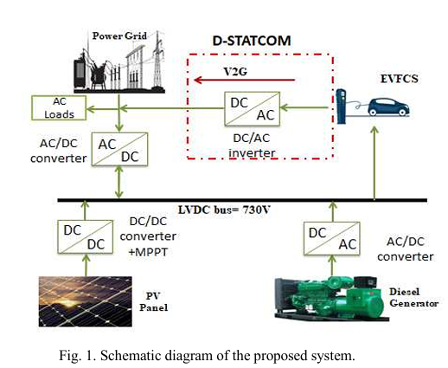
Fig. 1. Schematic diagram of the proposed system.
SOLAR PV GENERATION
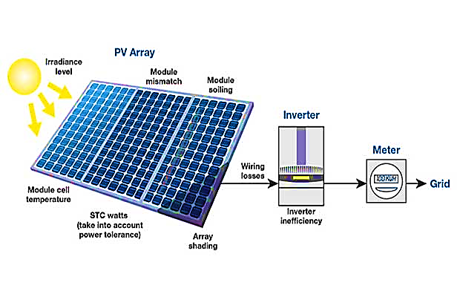
Fig. solar PV generation
Introduction
Solar PV generation is the process of generating electricity from sunlight through the use of solar PV technology. Solar PV systems transform solar energy into DC electricity, which can subsequently be converted into AC electricity that is suitable for powering residential and commercial buildings, as well as other electrical loads.
A solar PV system comprises fundamental components such as solar panels, an inverter, and a mounting system. Solar panels contain numerous solar cells that transform sunlight into DC electricity. The inverter converts DC into AC, which can be utilized to power electrical loads or supplied back to the grid. The mounting system is responsible for securing the solar panels in position and ensuring they are oriented towards the sun for optimal energy generation.
Solar PV generation has become an increasingly important source of renewable energy, as the cost of solar PV systems has decreased over time and their efficiency has increased. Solar PV systems can be installed on rooftops or on the ground, and can range in size from small residential systems to large-scale utility systems that generate megawatts of electricity.
One of the main advantages of solar PV generation is that it produces electricity without emitting greenhouse gases or other pollutants, making it a clean and sustainable source of energy. Additionally, solar PV systems can provide power in remote locations where access to electricity is limited or expensive, and can reduce reliance on fossil fuels and the grid.

Photo-Voltaic (PV) Cell, Module and Array:
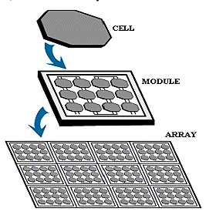
Fig. Cell Module and Array
PV Cell
A PV cell, commonly known as a solar cell, is a device that harnesses the energy from light and converts it into electricity using the PV effect. These cells are usually made of semiconductor materials like silicon and form the crucial building blocks of solar PV systems.
The photovoltaic effect takes place when photons of light energy are absorbed by the semiconductor material in a PV cell. This energy is then transmitted to electrons in the material, stimulating them and producing a flow of electric current. The current flow is subsequently gathered by metal contacts located on the cell and can be utilized as electrical energy.
The efficiency of a PV cell is determined by several factors, including the type of semiconductor material used, the thickness of the cell, and the manufacturing process. Most commercial PV cells have an efficiency ranging from 15% to 20%, with some advanced cells achieving efficiencies of over 25%.
PV cells can be used in a variety of applications, from small, portable devices like calculators and watches to large-scale solar PV systems that can power entire buildings or communities. PV cells are often combined into modules or arrays to provide the desired power output, and the arrays can be mounted on rooftops, on the ground, or in other locations where they can capture sunlight.
Overall, PV cells are a critical component of the solar PV industry, and their development and improvement is essential for expanding the use of solar energy as a renewable and sustainable source of electricity.

PV Module:
A PV module, also known as a solar panel, is a collection of interconnected PV cells that convert sunlight into electrical energy. The PV cells are typically made of silicon or other semiconductor materials and are housed in a protective casing with a glass cover to protect them from the elements.
A PV module is the basic building block of a solar PV system and is designed to produce a specific amount of electrical power. The power output number and size of the PV cells it contains, as well as the efficiency of the cells and the quality of the manufacturing process.
PV modules are designed to be connected together in a series or parallel configuration to create a solar PV array that can produce the desired amount of power. The array can be installed on a rooftop or on the ground, and can be used to power homes, businesses, and other electrical loads.
The efficiency of a PV module is an important factor in its performance, and manufacturers are constantly working to improve the efficiency of their products. Most commercial PV modules have an efficiency ranging from 15% to 20%, with some advanced modules achieving efficiencies of over 25%.
Overall, PV modules are a critical component of the solar PV industry, and their development and improvement is essential for expanding the use of solar energy as a renewable and sustainable source of electricity.
PV Array:
A PV array is a collection of interconnected PV modules that are designed to generate electrical power from sunlight. The PV modules are typically mounted on a support structure, such as a rooftop or ground-mounted system, and are connected together in series and/or parallel to produce the desired electrical output.
The size of a PV array depends on the amount of electrical power that is required and the available space for installation. PV arrays can range from small residential systems that generate a few kilowatts of power to large utility-scale systems that generate megawatts of power.
PV arrays are often used in combination with other components, such as inverters and batteries, to create a complete solar PV system. Inverters are employed to convert the DC power generated by the PV panel into AC power that is suitable for powering electrical loads or can be supplied back to the grid. Excess energy generated by the PV array can be stored using batteries for utilization during periods when the sun is not available, such as cloudy weather or nighttime.
The performance of a PV array is affected by a number of factors, including the amount of sunlight available, the angle and orientation of the array, and the temperature of the PV modules. Proper design, installation, and maintenance of a PV array is essential to ensure that it operates efficiently and reliably over its lifetime.
Overall, PV arrays are a critical component of the solar PV industry, and their development and improvement is essential for expanding the use of solar energy as a renewable and sustainable source of electricity.
Working of PV cell:
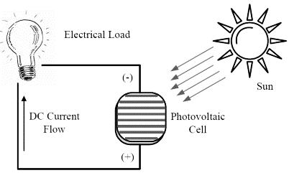
Fig. working of PV Cell
A solar cell, also known as a PV cell, converts light energy into electric energy using the photovoltaic effect. This effect occurs as photons are absorbed by a semiconductor material, typically silicon, resulting in the generation of electric energy.
A solar cell is composed of a pair of slim layers of semiconductor material, with one layer functioning as n-type and the other as p-type. The n-type material has a surplus of available electrons, while the p-type material has a shortage of electrons, or "holes." As light energy shines onto the PV cell, the electrons in the n-type material are stimulated and migrate to the p-type material, resulting in the creation of an electric current within the cell that can be collected through metal contacts.
The electricity generated by the PV cell is in the form of direct current (DC), which can be utilized to power electrical loads, or it can be transformed into alternating current (AC) electricity through an inverter to power homes, businesses, and other electrical devices.
The efficiency of a PV cell is affected by several factors, including the type and quality of the semiconductor material, the thickness of the cell, and the quality of the manufacturing process. Most commercial PV cells have an efficiency ranging from 15% to 20%, with some advanced cells achieving efficiencies of over 25%.
Overall, PV cells are a critical component of the solar PV industry, and their development and improvement is essential for expanding the use of solar energy as a renewable and sustainable source of electricity.
Modeling of PV cell:
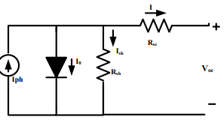
Fig. Solar cell equivalent model
PV cell modeling involves developing mathematical equations and models that describe the behavior of the cell under different operating conditions, such as changes in temperature, irradiance, and load. These models are used to simulate the electrical performance of the cell and to optimize the design and operation of PV systems.
There are several approaches to PV cell modeling, including analytical, numerical, and empirical methods. Analytical models use mathematical equations to describe the physical and electrical properties of the cell, while numerical models use computer simulations to solve complex equations and generate detailed performance predictions. Empirical models use experimental data to develop relationships between the cell's electrical output and the input parameters, such as irradiance and temperature.
The most commonly used analytical model for PV cells is the single-diode model, which describes the cell's electrical behavior using a single diode and resistor. The model includes several parameters that describe the cell's physical and electrical properties, such as the short-circuit current, open-circuit voltage, and ideality factor.
Numerical models can provide more accurate and detailed predictions of the cell's behavior, but are more computationally intensive and require more detailed input data, such as the cell's material properties and geometry.
Empirical models are often used for PV cells that are difficult to model analytically or numerically, such as cells with non-uniform doping profiles or complex geometries. These models are typically developed using experimental data and statistical analysis techniques.
Overall, PV cell modeling is an important tool for understanding and optimizing the performance of PV cells and systems, and is essential for the continued development and improvement of solar energy technology.
SOLAR MPPT TOPOLOGIES
Solar PV systems utilize a technique called maximum power point tracking (MPPT) to increase the energy production of PV modules by adjusting the system's operating point to follow the MPP of the modules. There are various MPPT topologies that can be utilized in PV systems, including:
P&O is a well-known MPPT technique that intermittently perturbs the operating point of a PV system and monitors the corresponding power output. If the power output increases, the system continues in that direction, otherwise, it reverses its direction until it locates the MPP.
Incremental Conductance - This method is similar to P&O, but it also considers the change in conductance in addition to the change in power output. This approach can result in faster tracking and more accurate MPP detection.
The FOCV is an MPPT method that estimates the Maximum Power Point (MPP) of a PV module by using its open-circuit voltage (Voc), which varies linearly with irradiance. The system adjusts the operating point to maintain a fixed fraction of the Voc, allowing it to track the MPP.
The Fractional Short-Circuit Current (FSCC) method is comparable to FOCV, but instead of open-circuit voltage (Voc), it utilizes the short-circuit current (Isc) of the PV module to estimate the MPP. It does so by adjusting the operating point to keep a constant fraction of the Isc, which varies linearly with irradiance. This enables the system to track the MPP.
Model Predictive Control (MPC) - This is a more advanced MPPT method that uses a mathematical model of the PV system to predict the future behavior of the system and optimize the operating point based on this prediction. MPC can provide faster and more accurate tracking, but requires more computational resources than other MPPT methods.
Overall, the choice of MPPT topology depends on the specific requirements and constraints of the PV system, such as the size and type of the PV modules, the operating conditions, and the desired level of performance and efficiency.

WIND POWER GENERATION
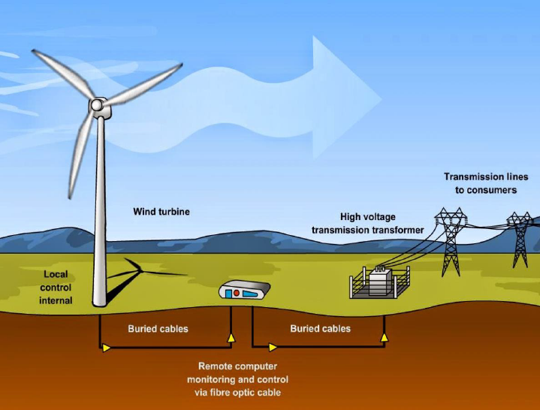
Fig. wind power generation
A wind power generation system is a renewable energy technology that transforms wind energy into electrical energy using wind turbines. Large blades that revolve when the wind blows compensate a wind turbine, which drives a generator to generate power. Wind turbine, tower, rotor blades, nacelle and control systems are the primary elements of a wind power producing system. To transform the electricity into a usable form and transport it to the grid, the system also involves electrical infrastructure like transformers and inverters.
Were there is various kinds of wind turbines, such as horizontal and vertical axis turbines, each with distinct benefits and drawbacks. Wind turbines can be installed onshore or offshore, and wind farms can range from small-scale systems for individual homes to large utility-scale projects that can power entire communities. Wind power generation systems are considered a clean and sustainable source of energy as they do not produce greenhouse gas emissions or other pollutants associated with conventional power. However, the construction and operation of wind turbines can have impacts on wildlife, local communities, and the environment, and careful planning and management are needed to mitigate these impacts.
WIND POWER:
The production of electrical energy from the wind is referred to as wind power. Wind turbines can be used to generate. It is a sustainable and renewable source of energy. Wind power has become an increasingly popular source of renewable energy in recent years, as it is environmentally friendly and does have gas emissions. Wind turbines are typically installed in areas with consistent wind patterns, such as coastal regions or open fields. The turbines are designed with large blades that are rotated by the wind, and the rotation of the blades drives a generator that produces electricity. The electricity can be used to power homes, businesses, and entire communities, or it can be fed into the electrical grid for distribution to other locations.
There are a number of advantages to using wind power, including its sustainability, environmental friendliness, and low cost of operation. However, wind power can also face challenges, such as the need for large land areas, potential noise pollution, and the variability of wind patterns. Despite these challenges, wind power is plays an important role in the global energy work to transition to more sustainable energy sources.
Characteristics of wind power:
Here are some characteristics of wind power:
Renewable: Wind power is a renewable energy source, which means that it can be replenished naturally over time. As long as wind exists, wind power can be generated, unlike fossil fuels that are finite resources.
Abundant: Wind is a widely available resource, and wind power can be harnessed in many locations across the globe, including onshore and offshore.
Variable: Wind power output can vary greatly varying the wind speed and direction, which can impact its reliability as a primary energy source. Wind turbines also require minimum wind speeds to produce electricity, and when winds exceed a certain threshold, they can cause turbine blades to shut down for safety reasons.
Scalable: Wind power technology can be scaled to accommodate small or large energy demands, from small residential systems to large-scale wind farms.
Environmentally friendly: Wind power does not produce greenhouse gases, air pollution, or other harmful byproducts associated with fossil fuels. This makes it a cleaner alternative to traditional power sources.
Cost-effective: As technology improves, the cost of wind power continues to decline, making it increasingly competitive with other energy sources.
Land-intensive: Wind turbines require significant amounts of land, especially for larger wind farms. This can make it challenging to site wind turbines in some locations, such as densely populated areas or areas with limited land availability.
Noise pollution: Wind turbines can generate noise pollution, which can be disruptive to nearby communities. Modern turbines are designed to minimize noise, but it remains a consideration when planning wind power projects.
Wildlife impact: Wind turbines can pose a hazard to birds and bats, particularly when they are sited along migration routes. Proper siting and design can help to mitigate these impacts.

WIND GENERATOR
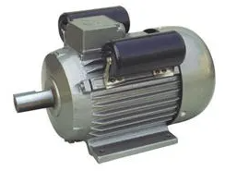
Fig. wind generator
A wind generator, also known as a wind turbine, is a device that converts the kinetic energy of the wind into electrical energy. Wind generators typically consist of a tower, a rotor, a generator, and other supporting components. The rotor, which is usually composed of two or three blades, is mounted on top of the tower and is designed to turn when the wind blows. As the rotor turns, it drives a generator that produces electricity. The electricity produced by the generator is typically either used immediately or stored in batteries for later use.
Wind generators come in a range of sizes, from small turbines that can power a single home to large turbines that can generate electricity for entire communities. They are often used in conjunction with other renewable energy sources, such as solar power, to provide a more reliable and consistent supply of electricity. One of the advantages of wind generators is that they are a clean and renewable source of energy, as they do not produce greenhouse gases or other pollutants that can harm the environment. However, they can also have negative impacts on wildlife and their installation and maintenance can be costly.
Types of Wind Turbine Generator
There are several types of wind generators, each with its own unique design and application. Here are some of the most common types:
- Single-phase AC generators: This type of wind generator produces alternating current (AC) power with a single-phase output. These generators are typically used in small-scale wind power systems, such as those used to power homes or small businesses.
- Three-phase AC generators: Three-phase AC generators produce AC power with a three-phase output, which is more efficient and provides a smoother power supply than single-phase generators. These generators are typically used in larger wind power systems, such as those used to power communities or industrial facilities.
- Direct-drive generators: Direct-drive generators eliminate the need for a gearbox by connecting the rotor directly to the generator. This design simplifies the system, reduces maintenance, and increases efficiency. Direct-drive generators are commonly used in larger wind turbines.
- Gear-driven generators: Gear-driven generators use a gearbox to connect the rotor to the generator. This allows the generator to spin faster than the rotor and increases the efficiency of the system. Gear-driven generators are commonly used in smaller wind turbines.
- Permanent magnet generators: Permanent magnet generators use powerful magnets to generate a magnetic field that produces electrical power. These generators are typically more efficient and require less maintenance than other types of generators.
- Induction generators: Induction generators use electromagnetic induction to generate electrical power. They are commonly used in larger wind turbines and are often less expensive than other types of generators.
Top of Form
Asynchronous generator
An asynchronous wind generator, also known as an induction generator, is a type of generator used in wind turbines to convert the kinetic energy of wind into electrical energy. Asynchronous generators are often used in larger wind turbines because they are more cost-effective than other types of generators, such as synchronous generators. Asynchronous generators work by using electromagnetic induction to generate electrical power. They consist of a rotor, which is mounted on a shaft, and a stator, which is a stationary component that contains the windings of the generator. When the rotor is turned by the force of the wind, it creates a rotating magnetic field that induces a current in the stator windings, which generates electrical power.
One of the key advantages of asynchronous generators is their simplicity. They do not require a direct connection to the grid and can operate independently, which makes them useful in remote locations. They also do not require the use of brushes or slip rings, which reduces maintenance requirements. However, asynchronous generators do have some drawbacks. They are less efficient than synchronous generators at low wind speeds, which can limit their performance in some wind conditions. They also require a capacitor bank to provide the necessary reactive power to operate, which can add to the cost of the system.

DESIGN OF WIND TURBINE:
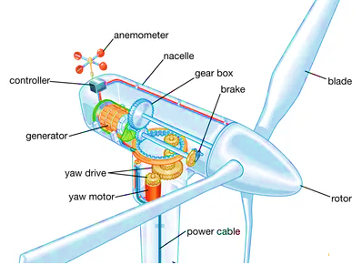
Fig. wind turbine
The design of a wind turbine involves several components that work together to capture the kinetic energy of the wind and convert it into electrical energy. Here are the main parts of a wind turbine:
The design of a wind turbine
Rotor blades: The blades are the most visible part of a wind turbine. They are designed to capture the wind and convert its kinetic energy into rotational energy. The blades are typically made of lightweight and durable materials, such as fiberglass or carbon fiber.
Rotor hub: The rotor hub is the central component that connects the rotor blades to the main shaft. The hub allows the blades to rotate and change pitch to optimize their angle of attack to the wind.
Nacelle: The nacelle is the housing that places at the top of the tower and contains the gearbox, generator, and other components that convert the rotational energy of the rotor into electrical energy. The nacelle also includes the yaw system, which enables the turbine to turn and face the wind.
Tower: The tower is the support structure that holds the rotor and nacelle at a height that maximizes the wind resource. Towers can be constructed from steel, concrete, or other materials.
Control system: The control system is the brain of the wind turbine. It monitors the wind direction and speed, adjusts the rotor blades to optimize their angle of attack, and controls the power output of the turbine.
The structure of a wind turbine is optimized for specific wind conditions, such as wind speed and turbulence. Modern wind turbines are designed to be highly efficient, with rotors that can adjust to varying wind conditions and control systems that can optimize power output. The size of wind turbines has also increased significantly in recent years, with some models reaching heights of over 200 meters and rotor diameters of up to 220 meters.
Wind power generation control:
Wind power generation control involves managing the output of wind turbines to maintain a stable and reliable supply of electrical energy. Here are some of the key aspects of wind power generation control:
Turbine control: Wind turbines are equipped with sensors and control systems that monitor wind speed and direction, and adjust the pitch and orientation of the blades to maximize energy capture. The control system also monitors the performance of the turbine and can shut it down if there are safety or performance issues.
Power output control: The power output of wind turbines can be controlled by adjusting the pitch angle of the blades or by limiting the amount of power that is fed into the electrical grid. This is important for maintaining grid stability and avoiding power imbalances that can cause blackouts or damage to the grid.
Grid integration: Wind turbines are typically connected to the electrical grid through power electronics that convert the variable output of the turbine into a stable, high-quality electrical signal that can be fed into the grid. Grid integration also involves managing the interaction between wind turbines and other power sources, such as conventional power plants or other renewable energy sources.
Forecasting and scheduling: Wind power generation control also involves forecasting the expected output of wind turbines based on weather conditions and scheduling their operation to meet the needs of the grid. This helps to avoid overloading the grid and ensures that wind power is available when it is needed.
Energy storage: Energy storage technologies, such as batteries or pumped hydro storage, can be used to store excess wind power and release it during times of high demand. This helps to improve the reliability and stability of wind power generation and makes it easier to integrate into the electrical grid.
Overall, wind power generation control is a complex process that involves balancing the variable output of wind turbines with the needs of the electrical grid. As wind power continues to play an increasingly important role in the global energy mix, the development of new control technologies and strategies will be critical for ensuring its reliability and effectiveness.

GRID
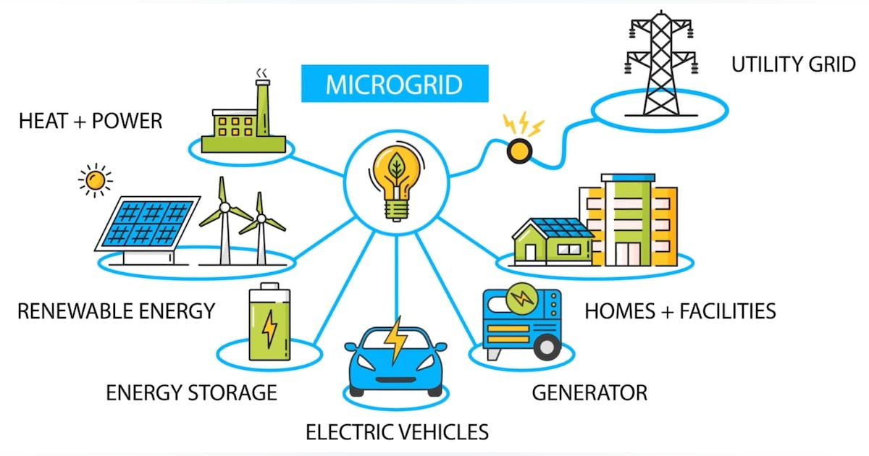
Fig. micro grid
The term "grid" refers to the complex network of power generation, transmission, and distribution infrastructure that is responsible for delivering electricity from power plants to homes, businesses, and other facilities.
The system can be divided into three main parts: power generation, transmission, and distribution. Electricity is produced by power plants using a range of sources such as coal, natural gas, nuclear, wind, solar, hydro, and geothermal. The electricity is then transmitted through the transmission system.
Transmission: Electricity is transported over extended distances from power plants to substations using high-voltage transmission lines. The transmission system is optimized to operate at voltages between 69 kV and 765 kV, with the goal of reducing losses and maintaining a stable supply of electricity.
Distribution: The distribution system delivers electricity from substations to homes, businesses, and other facilities. The distribution system operates at lower voltages, typically ranging from 120 V to 480 V, and it is designed to provide reliable and efficient electricity to end-users.
Load Balancing: Grid operators must constantly balance the supply and demand of electricity to maintain a stable frequency and voltage on the grid. This involves monitoring the output of power plants and adjusting the generation output to match the demand for electricity.
Grid Control: To maintain the reliability and safety of the grid, grid operators utilize different control systems and technologies. These systems and technologies include Supervisory Control and Data Acquisition (SCADA) systems that monitor and control the grid in real-time, and Automatic Generation Control (AGC) systems that regulate the generation output to match electricity demand.
Grid Security: The grid is also protected by various security measures, such as physical security measures, cybersecurity measures, and emergency response plans.
Overall, the operation of the grid is a complex and dynamic process that involves the coordination of many different systems and stakeholders. However, the result is a reliable and stable supply of electricity that powers our homes, businesses, and communities.
The grid is managed and operated by utility companies, which are responsible for maintaining the infrastructure and ensuring the reliability and safety of the electrical system. The grid is also regulated by government agencies to ensure that it meets certain standards and provides affordable and accessible electricity to consumers.
The grid has undergone significant changes in recent years, driven by advances in technology, changes in energy policies, and increasing demand for renewable energy. These changes include the integration of renewable energy sources, such as wind and solar, the deployment of smart grid technologies, and the development of energy storage systems to support the integration of intermittent renewable energy sources.
TYPES OF GRIDS
There are different types of grids based on various factors, such as the size of the grid, the location of the grid, and the types of power sources used. Here are some of the types of grids:
National Grid: A national grid is a large-scale network that connects power plants and distribution systems across a country. National grids are typically operated by a government agency or a regulated utility company.
Regional Grid: A regional grid is a smaller-scale network that connects power plants and distribution systems within a specific geographic region. Regional grids are often connected to national grids and are operated by utility companies.
Microgrid: A microgrid is a compact grid that can function autonomously or in conjunction with a bigger grid. It usually employs dispersed energy resources (DERs) like energy storage systems, wind turbines, and solar panels to provide electricity to a small community or facility.
Off-Grid: An off-grid system is a standalone system that is not connected to a larger grid. RES, such as solar panels and wind turbines, are commonly used in off-grid systems or hydroelectric generators, to generate electricity and may include energy storage systems to provide power when the renewable sources are not available.
Hybrid Grid: A hybrid grid is a combination of different types of power sources, such as renewable energy sources and traditional power plants, to provide a reliable and sustainable supply of electricity.
Smart Grid: A smart grid is a modern grid that incorporates advanced technologies, such as sensors, communication networks, and data analytics, to optimize the efficiency, reliability, and sustainability of the grid.
The type of grid used in a particular location will depend on various factors, such as the availability of resources, the size of the population, and the demand for electricity.
Working of grid
The term "grid" can refer to a variety of different things depending on the context, but in general, a grid is a system of interconnected elements that work together to accomplish a particular goal.
In the context of power generation and distribution, the grid refers to the network of power lines, substations, transformers, and other infrastructure that allows electricity to be generated at power plants and transmitted to homes and businesses. The grid is designed to be highly reliable and resilient, with multiple redundant pathways and backup systems to ensure that power is always available, even in the event of equipment failures or other disruptions.
The grid operates based on a complex system of supply and demand. Power plants generate electricity and feed it into the grid, where it is distributed to consumers based on their demand. In order to maintain a stable electrical supply, the grid operators must balance the supply and demand in real-time, constantly adjusting the flow of electricity to ensure that there is always enough power to meet the needs of the consumers without overwhelming the system.
In addition to power generation and distribution, the term "grid" can also refer to other types of interconnected systems, such as transportation networks, communication networks, and data networks. In each case, the goal is to create a highly efficient and reliable system that can deliver goods, services, or information to users in a seamless and efficient manner.
Advantages
The advantages of grids depend on the specific type of grid being considered. Here are some general advantages of different types of grids:
Power grids:
- Provides a reliable supply of electricity to homes, businesses, and other users
- Enables the integration of renewable energy sources into the grid, reducing reliance on fossil fuels and lowering carbon emissions
- Allows for the implementation of demand response programs that incentivize users to reduce electricity consumption during times of peak demand, helping to prevent blackouts and brownouts
- Enables the efficient distribution of electricity over long distances, reducing the need for local generation facilities
Computing grids:
- Provides a platform for high-performance computing, enabling the processing of large datasets and complex computations that would not be possible with a single computer
- Facilitates collaboration among researchers and organizations by providing a shared computing resource
- Increases reliability by providing redundancy and fault tolerance, ensuring that computing tasks are completed even if individual computers fail
- Enables cost savings by allowing organizations to share computing resources and reduce the need for dedicated computing infrastructure
Spatial grids:
- Provides a consistent framework for organizing and analyzing spatial data, facilitating spatial analysis and modeling
- Enables the efficient sampling of spatial data for scientific studies, reducing the need for expensive and time-consuming field surveys
- Facilitates communication and collaboration among researchers and stakeholders by providing a common reference framework for discussing spatial data
- Enables the development of spatially explicit models that can be used to make predictions and inform decision-making.
Overall, grids provide a way to organize and coordinate resources in a way that is efficient, reliable, and flexible. They allow us to accomplish tasks that would not be possible with individual resources, and they enable collaboration and innovation across different domains.
Applications
The term "grid" can refer to a number of different things, including power grids, computing grids, and spatial grids. Here are some applications of each:
Power grids: Power grids are networks of interconnected power generation, transmission, and distribution facilities that provide electricity to homes, businesses, and other users. Some applications of power grids include:
- Enabling the reliable delivery of electricity to homes and businesses
- Supporting the integration of renewable energy sources into the grid
- Facilitating the implementation of demand response programs that incentivize users to reduce electricity consumption during times of peak demand
- Providing a platform for electric vehicle charging stations to connect to the grid
Computing grids: Computing grids are networks of computers that are connected together to perform large-scale computing tasks. Some applications of computing grids include:
- Enabling high-performance computing for scientific research and other applications
- Supporting the development and testing of complex software applications
- Facilitating the processing of large datasets for machine learning and artificial intelligence applications
- Providing a platform for distributed computing projects, such as SETI@home, that rely on volunteer computers to perform computations
Spatial grids: Spatial grids are regular grids that are overlaid on geographic space to facilitate spatial analysis and modeling. Some applications of spatial grids include:
- Supporting the analysis of spatial data, such as satellite imagery and remote sensing data
- Facilitating the modeling of spatial phenomena, such as climate patterns and land use changes
- Providing a framework for geographic information systems (GIS) software to organize and analyze spatial data
- Enabling the design and implementation of spatial sampling schemes for scientific studies, such as ecological surveys

DSTATCOM
History
DSTATCOM stands for Distribution Static Compensator. It is a device used in electrical power systems to improve the power quality. DSTATCOM is a type of FACTS (Flexible AC Transmission System) device that provides reactive power compensation, voltage regulation, and load balancing in power systems.
The first known use of the term "DSTATCOM" is in a patent application filed by Satish Kumar in 2002. However, the concept of static compensation in power systems dates back to the early 1970s.
The first static compensator was the Static Var Compensator (SVC), which was developed in the early 1970s by Westinghouse Electric Corporation. SVC is a shunt-connected device that provides reactive power compensation to the system.
Later, a series-connected device called the Thyristor Controlled Series Compensator (TCSC) was developed. TCSC is used to increase the transmission line capacity and reduce the power losses.
In the late 1990s, DSTATCOM was developed to address the issues of voltage regulation and load balancing in distribution systems. DSTATCOM is a shunt-connected device that is used to compensate for the reactive power demand of the load and maintain the voltage within the acceptable limits.
DSTATCOM works by injecting or absorbing reactive power into the system. It uses a voltage source inverter (VSI) to generate the required reactive power. The VSI is controlled by a control system that monitors the voltage and current in the system and adjusts the VSI output accordingly.
Overall, the development of DSTATCOM was a significant step towards improving the power quality in distribution systems. It has become an important component in modern power systems, especially in the renewable energy integration era.

What is need of D STATCOM?
DSTATCOM, or Distribution Static Compensator, is a device used in electrical power systems to improve the power quality by providing reactive power compensation, voltage regulation, and load balancing. The need for DSTATCOM arises from the following reasons:
Reactive Power Compensation: Reactive power is required in the electrical system to maintain the voltage level within the desired range. The reactive power demand varies with the load, and the power factor of the load affects the system's reactive power demand. DSTATCOM provides the required reactive power to the system, thereby maintaining the voltage level within the acceptable limits.
Voltage Regulation: Voltage regulation is a critical aspect of the power system. The voltage level should be within the acceptable limits, which is usually ±5% of the nominal voltage. Voltage fluctuations can cause equipment failure and affect the power quality. DSTATCOM helps regulate the voltage by injecting or absorbing reactive power into the system.
Load Balancing: In a power system, the load is not distributed uniformly. Some loads may draw more current than others, resulting in an unbalanced load. An unbalanced load can cause voltage fluctuations and affect the power quality. DSTATCOM can balance the load by injecting or absorbing reactive power at different points in the system.
Integration of Renewable Energy Sources: With the increasing integration of renewable energy sources such as wind and solar, the power system's stability and reliability have become more critical. DSTATCOM can help mitigate the issues caused by the intermittent nature of renewable energy sources by regulating the voltage and providing reactive power compensation.
In summary, DSTATCOM is needed to maintain the power quality and stability of the electrical power system. It provides reactive power compensation, voltage regulation, and load balancing, making it an essential component of modern power systems.
WHAT IS D STATCOM
DSTATCOM stands for Distribution Static Compensator. It is a type of FACTS (Flexible AC Transmission System) device used in electrical power systems to improve the power quality by providing reactive power compensation, voltage regulation, and load balancing.
The primary function of DSTATCOM is to provide reactive power compensation to the system. Reactive power is required to maintain the voltage level within the desired range. The reactive power demand varies with the load, and the power factor of the load affects the system's reactive power demand. DSTATCOM provides the required reactive power to the system, thereby maintaining the voltage level within the acceptable limits.
DSTATCOM can also regulate the voltage and balance the load. Voltage regulation is critical in power systems as voltage fluctuations can cause equipment failure and affect the power quality. Load balancing is essential as the load is not distributed uniformly in a power system, and an unbalanced load can cause voltage fluctuations and affect the power quality.
Overall, DSTATCOM is an important device in modern power systems, especially in the renewable energy integration era. It helps maintain the power quality and stability of the electrical power system by providing reactive power compensation, voltage regulation, and load balancing.
WORKING
The working of DSTATCOM, or Distribution Static Compensator, involves injecting or absorbing reactive power into the electrical power system to regulate the voltage, provide reactive power compensation, and balance the load.
DSTATCOM is a shunt-connected device that is installed in parallel with the load. It consists of a voltage source inverter (VSI), a DC capacitor, a harmonic filter, and a control system. The VSI generates the required reactive power, and the DC capacitor stores the energy required for the operation of the VSI.
The control system of DSTATCOM monitors the voltage and current in the system and adjusts the output of the VSI accordingly. The control system also ensures that the output of the DSTATCOM is in phase with the supply voltage.
The operation of DSTATCOM can be divided into two modes: Capacitive Mode and Inductive Mode.
Capacitive Mode: In this mode, the DSTATCOM injects capacitive reactive power into the system, which helps to maintain the voltage level within the acceptable limits when the load is inductive. The VSI generates a voltage that is higher than the supply voltage, which allows the DSTATCOM to inject capacitive reactive power into the system.
Inductive Mode: In this mode, the DSTATCOM absorbs inductive reactive power from the system, which helps to maintain the voltage level within the acceptable limits when the load is capacitive. The VSI generates a voltage that is lower than the supply voltage, which allows the DSTATCOM to absorb inductive reactive power from the system.
The operation of DSTATCOM is continuous, and it adjusts the output of the VSI according to the changes in the system voltage and current. By providing reactive power compensation, voltage regulation, and load balancing, DSTATCOM helps to maintain the power quality and stability of the electrical power system.
In summary, the working of DSTATCOM involves injecting or absorbing reactive power into the system to regulate the voltage, providing reactive power compensation, and balancing the load. The control system of DSTATCOM monitors the system voltage and current and adjusts the output of the VSI accordingly.
ADVANATAGES
DSTATCOM, or Distribution Static Compensator, offers several advantages in improving the power quality and stability of the electrical power system. Here are some of the key advantages of DSTATCOM:
Reactive Power Compensation: DSTATCOM provides reactive power compensation to the system, thereby maintaining the voltage level within the acceptable limits. Reactive power compensation reduces the losses in the system and improves the power factor of the load, which leads to better efficiency and reduced energy consumption.
Voltage Regulation: DSTATCOM regulates the voltage by injecting or absorbing reactive power into the system. This helps to maintain the voltage level within the acceptable limits, which reduces the risk of equipment failure and improves the power quality.
Load Balancing: DSTATCOM balances the load by injecting or absorbing reactive power at different points in the system. This helps to prevent voltage fluctuations and reduces the risk of equipment failure.
Fast Response Time: DSTATCOM has a fast response time, which allows it to quickly respond to changes in the system voltage and current. This makes it an effective solution for maintaining the power quality and stability of the electrical power system.
Improved Power Factor: DSTATCOM improves the power factor of the load by providing reactive power compensation. This reduces the reactive power demand from the system and improves the efficiency of the power system.
Integration of Renewable Energy Sources: DSTATCOM helps to integrate renewable energy sources such as wind and solar into the power system by regulating the voltage and providing reactive power compensation. This improves the stability and reliability of the power system.
Overall, DSTATCOM offers several advantages in improving the power quality and stability of the electrical power system. It provides reactive power compensation, voltage regulation, load balancing, and fast response time, making it an essential component of modern power systems.
DISADAVANTAGES
Although DSTATCOM offers several advantages, it also has some disadvantages that should be considered. Here are some of the potential drawbacks of DSTATCOM:
Cost: DSTATCOM is a relatively expensive technology compared to other power quality improvement technologies. The cost of installation, maintenance, and operation can be high, which may be a barrier to its widespread adoption.
Complex Control System: DSTATCOM requires a complex control system to regulate the voltage and provide reactive power compensation. The control system must be designed and configured carefully to ensure optimal performance and avoid any stability issues.
Harmonics: DSTATCOM can introduce harmonics into the system, which can cause interference with other electrical equipment and affect the power quality. The installation of harmonic filters can mitigate this issue, but it adds to the cost and complexity of the system.
Environmental Impact: The manufacturing and disposal of DSTATCOM components can have an environmental impact. The production of some materials used in DSTATCOM, such as capacitors and semiconductors, can be energy-intensive and generate hazardous waste.
Maintenance: DSTATCOM requires regular maintenance to ensure optimal performance. The maintenance can be costly, and the downtime required for maintenance can affect the power system's availability.
Overall, while DSTATCOM offers several advantages in improving power quality and stability, it is essential to consider its potential drawbacks, such as cost, complexity, harmonics, environmental impact, and maintenance requirements, before deciding to implement this technology.
APPLICATIONS
DSTATCOM, or Distribution Static Compensator, has several applications in power systems where power quality and stability are critical. Here are some of the common applications of DSTATCOM:
Voltage Regulation: DSTATCOM can be used to regulate the voltage in distribution systems, which can help to maintain the voltage within acceptable limits and improve the power quality.
Reactive Power Compensation: DSTATCOM can provide reactive power compensation to the system, which can help to reduce the reactive power demand from the system and improve the power factor of the load.
Load Balancing: DSTATCOM can balance the load by injecting or absorbing reactive power at different points in the system. This can help to prevent voltage fluctuations and reduce the risk of equipment failure.
Integration of Renewable Energy Sources: DSTATCOM can be used to integrate renewable energy sources such as wind and solar into the power system by regulating the voltage and providing reactive power compensation. This can help to improve the stability and reliability of the power system.
Industrial Applications: DSTATCOM can be used in industrial applications where power quality and stability are critical, such as in steel mills, chemical plants, and other manufacturing facilities.
Transportation Applications: DSTATCOM can be used in transportation applications, such as railway systems, to provide voltage regulation and reactive power compensation, which can help to improve the reliability and efficiency of the system.
Overall, DSTATCOM has several applications in power systems where power quality and stability are critical, and it can be used in various industrial and transportation applications as well.

ELECTRIC VEHICLES
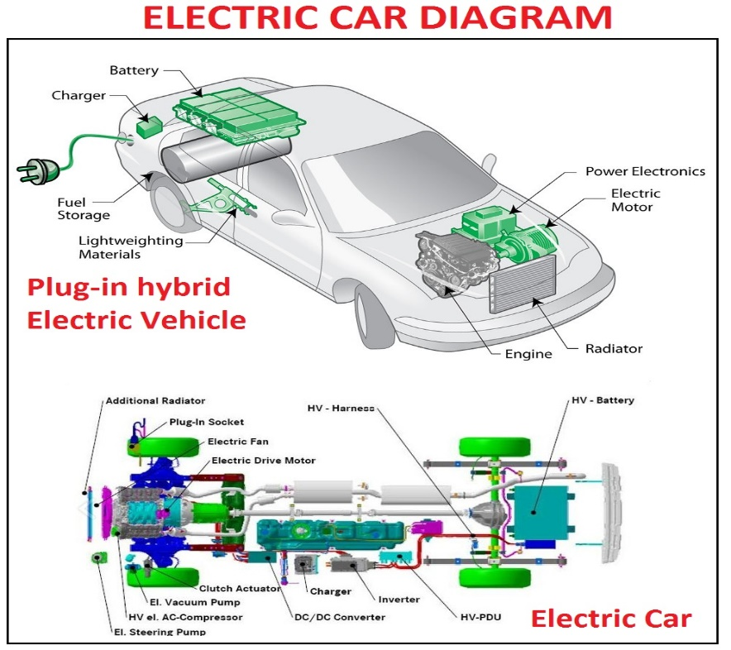
Fig. Electric Vehicle
INTRODUCTION
Electric vehicles (EVs) have a surprisingly long history that dates back to the early 19th century. The first electric vehicle was invented by Scottish inventor Robert Anderson in 1832, which used non-rechargeable primary cells. However, the first practical electric vehicle was not developed until the late 1800s.
In 1884, Thomas Parker, a British inventor, built the first practical electric car, which used lead-acid batteries and had a range of about 48 kilometers. By the turn of the century, electric cars were becoming increasingly popular, particularly in urban areas, as they were quiet, easy to operate, and did not produce exhaust emissions.
However, the invention of the gasoline-powered internal combustion engine and the mass production of automobiles by companies such as Ford quickly made gasoline-powered cars more affordable and popular. As a result, the popularity of electric cars declined, and they became a niche product.
In the 1970s, the oil crisis led to renewed interest in electric vehicles as a way to reduce reliance on imported oil. This led to the development of several new electric cars, including the General Motors EV1, which was introduced in the 1990s.
In the 2000s, advances in battery technology and the need to reduce greenhouse gas emissions from transportation led to a renewed interest in electric vehicles. Companies such as Tesla, Nissan, and General Motors began to produce modern electric cars with longer ranges and better performance.
Today, Electric cars are gaining more popularity and becoming more widespread, as numerous nations worldwide establish goals to eliminate petrol-fueled vehicles in the forthcoming years. The history of electric vehicles shows that while their popularity has waxed and waned over the years, they have the potential to be an important part of the transition to a more sustainable and low-carbon transportation system
What is the need of EVs?
Electric vehicles (EVs) are needed for several reasons:
Environmental concerns: EVs have the potential to reduce greenhouse gas emissions and improve air quality. They produce zero emissions at the tailpipe, which can help reduce the harmful effects of air pollution on human health and the environment.
Energy security: EVs can help reduce a country's dependence on foreign oil and increase energy security by using domestically-produced electricity.
Economic benefits: The production of EVs can create jobs in the manufacturing and supply chain sectors. Additionally, EVs have lower operating costs than traditional gasoline-powered vehicles, which can save consumers money in the long run.
Technological innovation: The development of EVs has spurred technological innovation in battery technology, charging infrastructure, and other related fields. This innovation can lead to new and improved products and services that benefit society as a whole.
Overall, EVs are an important tool for addressing climate change, improving air quality, enhancing energy security, and promoting economic development and technological innovation.
Working of EVs
Electric vehicles (EVs) operate using an electric motor and a rechargeable battery instead of an internal combustion engine. The battery stores electrical energy that powers the motor, which turns the wheels and propels the vehicle forward.
The process of powering an EV starts with plugging the vehicle into an electrical outlet or a charging station. The battery is charged using electricity from the grid, which is converted into direct current (DC) power and stored in the battery.
When the driver wants to move the vehicle, they activate the accelerator pedal. This sends a signal to the controller, which determines how much power to send from the battery to the motor. The motor then converts the electrical energy from the battery into mechanical energy, which turns the wheels and moves the vehicle forward.
As the vehicle moves, the battery gradually discharges, and the range of the vehicle decreases. When the battery level drops below a certain point, the driver needs to recharge the battery using a charging station or electrical outlet.
Regenerative braking is another important feature of many EVs. When the driver brakes, the motor acts as a generator and converts some of the vehicle's kinetic energy back into electrical energy, which is then used to recharge the battery. This helps to extend the range of the vehicle and improve overall energy efficiency.
Types of EVs
Electric vehicles (EVs) are vehicles that are powered by electric motors and batteries rather than by internal combustion engines that burn fossil fuels. There are several different types of EVs, including:
Battery Electric Vehicles (BEVs): These vehicles are powered solely by electricity and have no internal combustion engine. They are charged by plugging them into an external power source, such as an EV charging station, and can travel for hundreds of kilometers on a single charge.
Hybrid Electric Vehicles (HEVs): These automobiles are equipped with both an electric motor and an internal combustion engine that runs on gasoline. The electric motor provides assistance to the engine during acceleration and at lower speeds, resulting in improved fuel efficiency and reduced emissions.
Plug-in Hybrid Electric Vehicles (PHEVs): These vehicles are similar to HEVs, but they have larger batteries that can be charged by plugging them into an external power source. They can travel for a short distance on electric power alone before the engine takes over.
Fuel Cell Electric Vehicles (FCEVs): These automobiles employ hydrogen fuel cells to generate electricity that drives their electric motors. They produce no emissions other than water vapor.
Electric vehicles offer several advantages over traditional gasoline-powered vehicles, including:
Zero tailpipe emissions: EVs produce no exhaust emissions, making them much cleaner and less polluting than gasoline-powered vehicles.
Lower operating costs: Electric motors are more efficient than internal combustion engines, meaning that EVs are cheaper to operate and maintain.
Reduced dependence on oil: Electric vehicles can be powered by a variety of sources, including renewable energy sources like solar and wind power, reducing dependence on oil and other fossil fuels.
Quiet and smooth: Electric motors produce very little noise and vibration, making EVs quieter and smoother to drive than traditional vehicles.
Performance benefits: Electric motors provide instant torque, meaning that EVs can be very quick and responsive, and can offer a smooth and enjoyable driving experience.
Overall, electric vehicles are becoming an increasingly popular and important part of the transition to a more sustainable and low-carbon transportation system
ADVANTAGES
Electric vehicles (EVs) offer several advantages over traditional gasoline-powered vehicles, including:
Zero tailpipe emissions: EVs produce no exhaust emissions, making them much cleaner and less polluting than gasoline-powered vehicles. This can help to improve air quality and reduce the impact of transportation on public health and the environment.
Lower operating costs: Electric motors are more efficient than internal combustion engines, meaning that EVs are cheaper to operate and maintain. EVs also have fewer moving parts, which can reduce the need for maintenance and repairs.
Reduced dependence on oil: Electric vehicles can be powered by a variety of sources, including RES like solar and wind power, reducing dependence on oil and other fossil fuels. This can help to improve energy security and reduce the risk of price volatility associated with oil.
Quiet and smooth: Electric motors produce very little noise and vibration, making EVs quieter and smoother to drive than traditional vehicles. This can provide a more enjoyable driving experience and reduce noise pollution in urban areas.
Performance benefits: Electric motors provide instant torque, meaning that EVs can be very quick and responsive, and can offer a smooth and enjoyable driving experience. EVs can also be designed with a low center of gravity, which can improve handling and stability.
Cost savings: In many cases, EVs can provide significant cost savings over the lifetime of the vehicle. Although they may have a higher purchase price.
APPLICATIONS
Electric vehicles (EVs) have several applications and benefits, including:
Personal transportation: Electric cars, trucks, and motorcycles are increasingly being used as a primary means of transportation for individuals and families. EVs offer a more sustainable and environmentally friendly option compared to traditional gasoline-powered vehicles.
Public transportation: Many cities are adopting electric buses and trains as a way to reduce emissions and improve air quality. EVs can also provide a quieter and more comfortable ride for passengers.
Commercial transportation: Electric trucks and vans are becoming more common in commercial fleets, especially for last-mile delivery and urban transportation. Electric vehicles can offer lower operating costs and reduced maintenance needs, making them an attractive option for businesses.
Renewable energy integration: EVs can serve as a means of storing excess RES like wind and solar power. This helps to balance the grid and ensure a reliable supply of energy.
Emergency services: Electric vehicles are being used by emergency services like police, fire, and ambulance services. EVs offer fast and quiet response times, making them well-suited for urban environments.
Agriculture and mining: Electric tractors and mining equipment are becoming more common in these industries, offering a quieter and more sustainable option compared to traditional diesel-powered equipment.
Overall, the applications of EVs are diverse and offer a range of benefits, including reduced emissions, lower operating costs, and improved energy security.

LINEAR AND NON LINEAR LOADS
History
Linear and nonlinear loads are two types of electrical loads that can be found in various applications. Here is a brief overview of their history:
Linear Loads: Linear loads have been in use since the early days of electricity. They are characterized by a linear relationship between the voltage and current, meaning that the current drawn by the load is proportional to the voltage applied across it. This makes them easy to predict and analyze, and they are typically resistive loads such as incandescent lamps, heaters, and some types of motors.
Nonlinear Loads: Nonlinear loads, on the other hand, have a more complex relationship between voltage and current. They draw current that is not proportional to the voltage applied across them, and they are typically found in devices that require electronic control or contain switching components, such as computers, televisions, and other consumer electronics.
As electronics became more prevalent in the mid-20th century, nonlinear loads became more common. However, their non-linear characteristics created challenges in power quality, which led to the development of technologies like power factor correction and harmonic filters to mitigate their effects. Today, nonlinear loads are ubiquitous in modern electrical systems, and their proper management is a critical aspect of power system design and operation.
Where we use linear and non-linear loads
Linear and nonlinear loads are used in various applications. Here are some examples:
Linear Loads: Linear loads are typically used in applications where a predictable and proportional relationship between voltage and current is desired. Some common applications of linear loads include:
Incandescent lamps: Incandescent lamps are a type of linear load that converts electrical energy into light and heat through the resistance of a filament.
Heaters: Electric heaters are another type of linear load that convert electrical energy into heat through resistance.
Simple motors: Some types of motors, such as DC motors and induction motors, can be considered linear loads under certain conditions.
Nonlinear Loads: Nonlinear loads are typically used in applications where electronic control or switching is required. Some common applications of nonlinear loads include:
Personal computers: Personal computers contain a variety of nonlinear loads, including power supplies, monitors, and other peripherals.
LED lighting: LED lighting uses electronic drivers that can be considered nonlinear loads.
Variable speed drives: Variable speed drives are used to control the speed of motors and are a common type of nonlinear load.
It is important to note that nonlinear loads can cause power quality issues in electrical systems due to their non-linear characteristics, which can lead to harmonic distortion and poor power factor. Proper management of nonlinear loads is essential for maintaining a reliable and efficient electrical system.
Working
The working of linear and nonlinear loads is different due to their different electrical characteristics.
Linear Loads: Linear loads have a linear relationship between the voltage and current. This means that the current drawn by the load is proportional to the voltage applied across it. The electrical energy is converted into heat or light through the resistance of the load. In other words, a linear load simply resists the flow of current in a linear fashion, without any significant distortion of the current waveform.
For example, consider an incandescent lamp. As you increase the voltage applied across the lamp, the current drawn by the lamp will also increase proportionally. The electrical energy is converted into heat and light through the resistance of the filament in the lamp.
Nonlinear Loads: Nonlinear loads have a more complex relationship between voltage and current. They draw current that is not proportional to the voltage applied across them, and the current waveform may be distorted. Nonlinear loads typically contain electronic components such as diodes, transistors, and power supplies, which can switch on and off rapidly to create the desired output.
For example, consider a personal computer. The computer contains a variety of nonlinear loads, including a power supply that converts AC voltage to DC voltage, and electronic components that switch on and off to control the flow of electrical current. The current waveform may be distorted due to the switching behavior of the electronic components.
It is important to note that nonlinear loads can cause power quality issues in electrical systems due to their non-linear characteristics, which can lead to harmonic distortion and poor power factor. Proper management of nonlinear loads is essential for maintaining a reliable and efficient electrical system.
Types of linear and non-linear loads
There are several types of linear and nonlinear loads. Here are some examples:
Linear Loads:
Resistive loads: Resistive loads are linear loads that have a fixed resistance and convert electrical energy into heat. Examples include incandescent lamps and electric heaters.
Inductive loads: Inductive loads are linear loads that contain inductors, such as motors and transformers. Inductive loads store electrical energy in a magnetic field and release it as the magnetic field collapses.
Capacitive loads: Capacitive loads are linear loads that contain capacitors, such as some types of lighting ballasts. Capacitive loads store electrical energy in an electric field and release it as the electric field collapses.
Nonlinear Loads:
Switching loads: Switching loads are nonlinear loads that contain electronic components that switch on and off rapidly to create the desired output. Examples include personal computers, televisions, and variable speed drives.
Rectifiers: Rectifiers are nonlinear loads that convert AC voltage to DC voltage. They contain electronic components such as diodes and thyristors.
Power supplies: Power supplies are nonlinear loads that convert AC voltage to DC voltage and may contain switching components such as transformers and capacitors.
It is important to note that nonlinear loads can cause power quality issues in electrical systems due to their non-linear characteristics, which can lead to harmonic distortion and poor power factor. Proper management of nonlinear loads is essential for maintaining a reliable and efficient electrical system.
Advantages
Linear and nonlinear loads have different advantages depending on the application. Here are some advantages of each type of load:
Advantages of Linear Loads:
Simplicity: Linear loads are typically simpler and less complex than nonlinear loads, making them easier to design, install, and maintain.
Stability: Linear loads have a predictable and proportional relationship between voltage and current, which can provide stability and reliability in electrical systems.
Low harmonic distortion: Linear loads do not introduce significant harmonic distortion into the electrical system, which can help maintain power quality.
Advantages of Nonlinear Loads:
Efficiency: Nonlinear loads can be more efficient than linear loads, particularly in applications where electronic control or switching is required.
Flexibility: Nonlinear loads can be designed to provide a wide range of output voltages and currents, making them versatile and flexible for different applications.
Compact size: Nonlinear loads can be more compact and lightweight than linear loads, making them suitable for applications where space is limited.
It is important to note that nonlinear loads can cause power quality issues in electrical systems due to their non-linear characteristics, which can lead to harmonic distortion and poor power factor. Proper management of nonlinear loads is essential for maintaining a reliable and efficient electrical system.
Disadvantages
Linear and nonlinear loads also have different disadvantages depending on the application. Here are some disadvantages of each type of load:
Disadvantages of Linear Loads:
Limited functionality: Linear loads are limited in their ability to provide complex functions and may not be suitable for applications that require advanced control or switching.
Poor efficiency: Linear loads are generally less efficient than nonlinear loads, particularly in applications where high power consumption is required.
Heat generation: Linear loads convert electrical energy into heat, which can result in significant heat generation and may require additional cooling measures.
Disadvantages of Nonlinear Loads:
Power quality issues: Nonlinear loads can cause power quality issues in electrical systems due to their non-linear characteristics, which can lead to harmonic distortion and poor power factor.
Complexity: Nonlinear loads are generally more complex and may require more advanced design, installation, and maintenance.
Interference: Nonlinear loads can introduce electromagnetic interference (EMI) into electrical systems, which can affect other equipment and devices.
It is important to note that both linear and nonlinear loads have their own advantages and disadvantages, and the choice of load type depends on the specific application and requirements. Proper management and control of both linear and nonlinear loads is important for maintaining a reliable and efficient electrical system.
Applications
Linear and nonlinear loads have a wide range of applications across various industries. Here are some common applications of each type of load:
Applications of Linear Loads:
Lighting: Incandescent lamps and fluorescent lamps are linear loads commonly used for lighting applications.
Heating: Electric heaters and baseboard heaters are linear loads used for space heating applications.
Motors: Induction motors are linear loads commonly used in industrial applications for driving pumps, fans, compressors, and other machinery.
Applications of Nonlinear Loads:
Electronics: Personal computers, televisions, and other electronic devices are nonlinear loads commonly used in homes and offices.
Power supplies: Switching power supplies are nonlinear loads commonly used in electronic devices and industrial equipment to convert AC voltage to DC voltage.
Variable speed drives: Nonlinear loads such as variable frequency drives (VFDs) are used to control the speed of motors in industrial applications, providing energy savings and process control.
It is important to note that the choice of load type depends on the specific application and requirements. Proper management and control of both linear and nonlinear loads is important for maintaining a reliable and efficient electrical system.

- DECENTRALIZED CONTROL SYSTEM BASED ON PI CONTROLLERS
In the study, a decentralized control system (DCS) is adopted, which means that each component of the charging station works independently from the rest of the system. Thus, independent controllers based on PI systems are developed for the power converters of the diesel generator and the grid. This control system is preferred as it allows an easy integration of new elements to the EVFCSs without affecting on the other elements of the system.
With regard to the PV system, as the main objective of the boost converter is to track the maximum power point of the PV array by regulating the solar panel terminal voltage using the power voltage characteristic curve, PV is assumed to work in the maximum power point tracking (MPPT) so that PI control is not necessary.
The main goal of this decentralized control is to maintain the LVDC bus voltage in a reference range and keep the power balance in the EVFCS. The LVDC bus is optioned by controlling the output of the diesel generator, PV system and grid at the voltage reference.
III.A. Inverters control
The control objective of the voltage source AC/DC inverter is to maintain 730V DC-bus voltage for EVFSC. When energy production or load demand changes, the DC bus voltage is adjusted to the constant value so as to observe the power balance within the system and to exchange power between the microgrid and the grid. A control theory is proposed in this study using three PI controllers. It consists of one outer voltage loop and two current loops. Synchronization with the grid and diesel voltage is performed through a phase locked loop (PLL) [20].
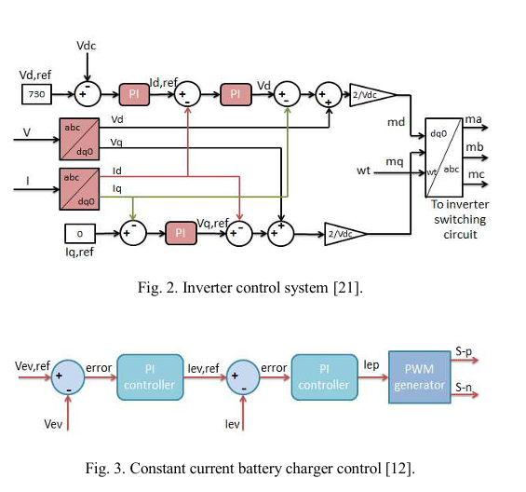
Fig.2 illustrates the proposed inverter control system, in which the DC bus voltage is controlled by the d-axis outer loop and the active AC current is controlled by the inner loop. The reactive current is set to zero. The PLL system uses the AC source voltage as an input and the output , and frequency signals are obtained for use in the frame inverter control [21]. The proportional and integral gain of PI controller are 0.5 and 200, which are obtained using the trial and-error method.
III.B. EV charger control
The EV battery charger control is designed based on the model described in [24]. The battery, power converter and controller are the three key components of the charging system. The control system consists of PI controllers, and the PWM generator is used to provide pulses to the IGBTs of the DC/DC converter, as shown in Fig. 3.

Depending on the desired charging method, two identical control approaches can be implemented: constant current (CC) and constant voltage (CV). CC strategy is a unified control method that is equivalent to use the battery as a current source and the output of PI controller defines the boost-mode operation of the EV charger. While CV strategy is equivalent to use the battery as voltage source and the output of PI controller defines the buck-mode operation of the EV charger [21], [24]. In this study, a CC control methodology is implemented to operate the battery as a current source. The PI controller parameters are 5 (kp ) and 0.0005 (ki ), respectively. Eqs. (1-4) show the algorithm that could perform PWM charger mode organically.
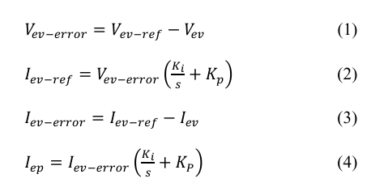
where is the EV battery voltage, is the battery current of the EV, is the pulse current and and are the reference EV battery charger voltage and current, respectively.
PI CONTROLLERS

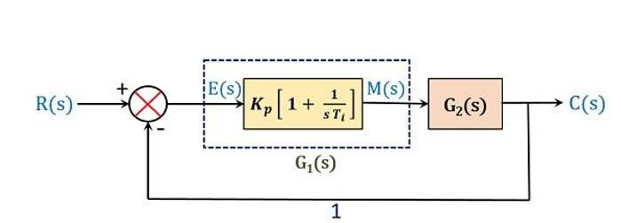
FIG. PI CONTROLLER
INTRODUCTION
Proportional-Integral (PI) controllers are a type of feedback control system commonly used in industrial automation and process control. They are a combination of two basic control techniques: proportional control and integral control.
Proportional control is a type of control that adjusts the output of a system in proportion to the difference between the desired set point and the actual output. The proportional controller calculates an error signal by subtracting the desired set point from the actual output and then multiplies this error signal by a proportional gain. The proportional gain determines how much the output should be adjusted for a given error signal.
Integral control, on the other hand, is a type of control that considers the accumulated error over time and adjusts the output accordingly. The integral controller calculates the integral of the error signal over time and multiplies this integral value by an integral gain. The integral gain determines how much the output should be adjusted for a given integral error signal.
A PI controller combines proportional and integral control to provide a more effective control system. The proportional component provides a fast response to changes in the error signal, while the integral component eliminates any steady-state error and ensures that the output converges to the set point over time.
PI controllers are widely used in process control applications, such as temperature, pressure, and flow control in chemical and manufacturing industries. They are also used in motion control systems, such as robot control and servo systems.
History
The proportional-integral (PI) controller is a type of feedback control system widely used in engineering applications to regulate various processes. The concept of PI controllers has been around for over a century, with various iterations and improvements made over time.
The earliest forms of PI control systems were developed in the late 1800s and early 1900s. One of the pioneers in this field was Nicolas Minorsky, who developed the first automatic steering system for ships in 1912. His system used a feedback mechanism to adjust the rudder angle in response to the ship's deviation from the desired course. Minorsky's system used both proportional and integral control to maintain a stable course and minimize oscillations.
The development of electronic control systems in the mid-20th century led to significant advancements in PI controllers. In the 1940s, Harold Black developed the negative feedback amplifier, which allowed for more precise control of electrical systems. This paved the way for the development of modern PID (proportional-integral-derivative) controllers, which incorporate a derivative term to improve system stability.
Since then, PI controllers have been widely used in various engineering applications, including process control, robotics, and automation. They are valued for their simplicity, ease of use, and effectiveness in regulating processes with varying dynamics and disturbances.
In recent years, advancements in computing and machine learning have enabled the development of more sophisticated control systems, including model-based predictive controllers and adaptive controllers. However, PI controllers continue to be widely used and are often the first choice for many engineering applications.
TYPES OF PI CONTROLLERS
There are several variations of PI controllers that are commonly used in industrial control systems. Some of the most common types include:
Standard PI Controller: This is the most basic type of PI controller, which combines proportional and integral control. The result produced by the controller is the combination of the proportional and integral components.
Series PI Controller: In this type of controller, the integral term is placed in series with the proportional term, rather than adding the two terms together. This type of controller is used when the system dynamics are slow compared to the rate of change of the input signal.
Parallel PI Controller: In this type of controller, the integral term is added in parallel with the proportional term. This type of controller is used when the system dynamics are fast compared to the rate of change of the input signal.
Non-interactive PI Controller: This type of controller separates the proportional and integral terms so that changes to one term do not affect the other. This can be useful in systems where the two terms have different effects on the system response.
Auto-tuning PI Controller: This type of controller automatically adjusts the gains of the proportional and integral terms based on the response of the system. This can be useful in systems where the system dynamics change over time or where the optimal gains are not known.
These different types of PI controllers have different advantages and disadvantages depending on the specific control application. The choice of controller type depends on the system dynamics, control objectives, and performance requirements of the specific control application.
Advantages of PI Controller:
Robustness: PI controllers are relatively simple and robust control systems that can handle a wide range of operating conditions.
Easy to implement: PI controllers are easy to implement in hardware and software, making them a popular choice in industrial control applications.
Fast response: PI controllers can respond quickly to changes in the system, allowing for fast and accurate control.
Reduces steady-state error: The integral component of the PI controller helps to eliminate steady-state error in the system, ensuring that the output converges to the setpoint over time.
Applications of PI Controller:
Temperature control: PI controllers are commonly used to control the temperature of industrial processes, such as in chemical and manufacturing industries.
Pressure control: PI controllers are used to control pressure in pneumatic and hydraulic systems.
Motion control: PI controllers are used in motion control systems, such as robot control and servo systems, to achieve precise and accurate control.
Speed control: PI controllers are used to control the speed of motors in industrial applications.
Flow control: PI controllers are used to control the flow of fluids in pipelines and other industrial processes.
Level control: PI controllers are used to control the level of liquids in tanks and other containers.
Overall, PI controllers are a popular and effective control system that can be applied to a wide range of industrial and process control applications. They are easy to implement, provide fast and accurate control, and help to eliminate steady-state error in the system.

PULSE WIDTH MODULATION
History
Pulse Width Modulation (PWM) is a technique used to control the amount of power delivered to a load by varying the width of a pulse of a fixed frequency. The concept of PWM has been around since the early days of radio communication, but it wasn't until the development of transistors and integrated circuits that it became practical for widespread use.
The earliest recorded use of PWM can be traced back to the 1940s when it was used in radio communication for amplitude modulation (AM). In AM, the amplitude of the carrier signal is varied to transmit information. However, varying the amplitude of the carrier signal resulted in the transmission of a lot of wasted energy in the form of heat. PWM was introduced as a more efficient way of transmitting the signal by turning the carrier signal on and off rapidly, creating a series of pulses whose width varied depending on the amplitude of the original signal.
In the 1960s and 1970s, PWM was widely adopted in industrial applications for controlling the speed of electric motors. This was made possible by the development of solid-state power electronics that could switch large currents on and off rapidly.
With the advent of microcontrollers and digital signal processing in the 1980s and 1990s, PWM became an even more versatile technique for controlling a wide range of devices. Today, PWM is widely used in electronic devices, such as audio amplifiers, LED lighting, and motor control systems.
Overall, the history of PWM has been marked by its evolution from a simple modulation technique in radio communication to a versatile control technique in various industrial and electronic applications.
INTRODUCTION
The utilization of PWM extends to certain communication systems, where the duty cycle is employed to transmit information over a communication channel.
In telecommunications, pulse width modulation (PWM) refers to a type of signal modulation in which the widths of pulses correspond to particular data values encoded at the transmitter and decoded at the receiver. The information itself is transmitted through pulses of varying durations sent at regular intervals, which is typically the carrier frequency of the modulation.
Pulse width modulation (PWM) is a method employed to regulate the power supplied to electrical components like LEDs or motors. The technique involves rapidly switching the power on and off at a high frequency, typically ranging from several kilohertz to several megahertz. The duty cycle of the power signal, which denotes the proportion of the on-time to the off-time, can be altered to control the amount of power delivered to the device.
The basic principle of PWM is to create a constant-amplitude, variable-frequency waveform that can be easily filtered to produce a smooth, stable DC voltage or current. By adjusting the duty cycle of the waveform, the effective voltage or current delivered to the load can be controlled.
PWM is widely used in electronic devices and systems, including motor control, power supplies, lighting control, audio amplifiers, and more. It is a very efficient way to control power, as the power losses in the switching devices are minimized by turning them on and off quickly.
PWM can also be used for other purposes, such as digital signal modulation and control of servo motors. In these applications, the pulse width and frequency of the waveform are modulated to encode digital data or control the position of the servo motor.
TYPES OF PULSE WIDTH MODULATION
There are several types of pulse width modulation (PWM) techniques, which differ in how the on-time and off-time of the signal are controlled. The most common types of PWM include:
Single-pulse width modulation: In this technique, a single pulse is generated for each control cycle, with the width of the pulse being adjusted to regulate the power supplied to the load. This method is simple and easy to implement, but can lead to high ripple in the output voltage or current.
Multiple-pulse width modulation: This technique uses multiple pulses per control cycle, with each pulse having a different width. By adjusting the widths of the pulses, a smooth, stable output voltage or current can be achieved.
Sinusoidal pulse width modulation: This technique is used in AC motor control applications, and generates a series of pulses that mimic a sine wave. The width of each pulse is adjusted to control the power delivered to the motor, resulting in smooth, efficient motor control.
Random pulse width modulation: In this technique, the width of each pulse is randomly varied within a specified range. This helps to reduce electromagnetic interference (EMI) in the system, but can also increase the complexity of the control circuitry.
Hybrid pulse width modulation: This technique combines two or more of the above methods to achieve the desired level of control and efficiency. For example, it may use multiple pulses with sinusoidal shapes to achieve both efficient power delivery and smooth motor control.
Each type of PWM has its own advantages and disadvantages, and the choice of which technique to use depends on the specific application and requirements of the system.
ADVANTAGES
Pulse Width Modulation, has several advantages, including:
Efficiency: PWM is an efficient way to control the power supplied to electrical devices. By switching the power on and off rapidly, PWM can regulate the amount of power that is supplied to the device, reducing waste and conserving energy.
Precise control: PWM allows for precise control over the voltage or current supplied to a device, making it ideal for controlling the speed of motors, dimming lights, or controlling the temperature of a heating element.
Low heat generation: Because PWM controls the power supply by switching it on and off, it generates less heat than other methods of power regulation, such as linear regulation.
Cost-effective: PWM is a cost-effective method of power regulation, as it requires fewer components than other methods and can be easily implemented using microcontrollers or other digital circuits.
Flexibility: PWM can be used to control a wide range of devices, from simple LEDs to complex motors, making it a versatile tool for many applications.
Overall, PWM is an efficient, precise, and cost-effective way to regulate power and control devices.
Applications
PWM, or Pulse Width Modulation, has a wide range of applications in various fields, including:
Motor speed control: PWM can be used to control the speed of DC motors, such as those used in robotics, industrial automation, and electric vehicles.
LED dimming: PWM can be used to dim the brightness of LEDs in lighting applications, such as in homes, buildings, and automobiles.
Audio amplification: PWM can be used to amplify audio signals, such as in digital audio amplifiers and home theater systems.
Solar power management: PWM can be used to manage solar power, by controlling the voltage and current supplied to batteries and other devices in solar power systems.
Power supply regulation: PWM can be used to regulate the power supply to electronic devices, such as computers, televisions, and smartphones.
Heating control: PWM can be used to control the temperature of heating elements, such as those used in ovens, toasters, and electric stoves.
Battery charging: PWM can be used to charge batteries, by controlling the voltage and current supplied to them, ensuring safe and efficient charging.
Overall, PWM is a versatile tool that can be used in a wide range of applications where precise control of power is required.
- VOLTAGE SAG/SWELL MITIGATION WITH EV BATTERY-INTEGRATED D-STATCOM
As EV battery with V2G can be used for peak shaving or valley falling and it contributes significantly to grid stability [18], EV battery in V2G mode can also be used as DC voltage source in D-STATCOM device to improve power quality. In order to have flexible charging or discharging rates as shown in Fig. 4, the charging and discharging are separated at the AC-DC converter stages [25]. The system consists of bidirectional DC-DC converter and two AC/DC converters for two-way operation.
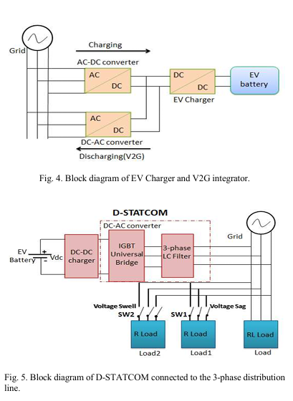
D-STATCOM is a shunt-connected power electronics based device, which is generally connected near the load at the distribution systems to mitigate power quality problems such as voltage sag, voltage swell and harmonics[26]. In general, D-STATCOM consists of four main parts, namely, voltage source inverter (VSI), LC filter, control circuit and DC source, as shown in Fig. 5.

In this work, EV is proposed as a DC source for the D STATCOM and PI controller shown in Fig. 6 is proposed to regulate the required terminal voltage at the PCC where the sensitive loads are connected under system disturbances. The D-STATCOM and PI controller design procedure are adapted from [26] and the obtained parameter values are presented in Table II.

- SIMULATION RESULTS
EVFCS decentralized control strategy simulation with on board charging and discharging (D-STATCOM) modes is performed in MATLAB/Simulink environment. Three different energy sources are utilized for charging EVFCS based on a LVDC bus. Moreover, the results of using a D STATCOM grid connected in V2G (discharge) mode for voltage regulation are presented with PI control to maintain the point of common coupling voltage at a nominal value when a voltage sag or swell occurs on grid voltage.
V.A. Charging of EV battery
Battery SOC and current variations for the EV battery during charging mode for a period of 1 second are shown in Fig. 7. Fig. 7(a) and Fig. 7(b) refer to the battery SOC and charge current of 192 A. Besides, Figure 8 shows the desired DC bus voltage of 730 V, which is obtained under three charging sources. EVFCS is operated between 0 and 1 seconds, and the EV is simultaneously connected and charged from all the microgrid energy sources at the first 0.52 seconds. The PV and diesel generator are disabled from 0.52 to 1 seconds, and the EV is charged by drawing energy from the utility grid. Figure 8 also depicts the DC bus voltage response to the shifting of the energy sources. The voltage variation is less than 80 V in that case and it is stabilized in less than 0.2 seconds.
V.B. EV battery integrated D-STATCOM for voltage sag/swell mitigation
In this work, EV battery is proposed as a power supply to drive the D-STATCOM during discharging mode to mitigate voltage sag/swell. As shown in Fig. 9 and Fig. 10, the voltage sag is appeared in the period from 0.2 to 0.4 seconds when 20 kW heavy load (Load1) is added to the system by switching SW1. In this case, the voltage drops by almost 24.3% with respect to the reference rms value (from 317 V to 240 V). At 0.4 seconds, the SW1 is opened and stays throughout the rest of the simulation. On the other hand, voltage swell is occurred in the period from 0.6 to 0.8 seconds when 20 kW heavy load (Load2) is turned off by switching SW2. In that case, the voltage on the power line increases by almost 38.1% with respect to the reference rms value (from 317 V to 438 V) and at 0.8 seconds, the SW2 is closed and stays throughout the rest of the simulation. The percentage of sag/swell for the system is calculated by Eq. (6):
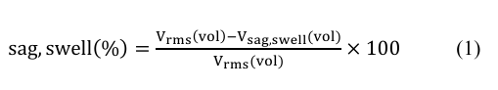
Based on Fig. 11 and Fig. 12, it is clear that the voltage sag/swell problems are mitigated when the proposed EV battery-connected D-STATCOM with PI voltage control strategy is injected in the distribution grid. During these periods, the EV will act as a DC source and begin to discharge its stored energy, as shown in Fig. 13(a). As a result, the EV voltage decreases and the EV current increases to compensate the voltage drop during voltage sag period as shown in Fig. 13(b) and Fig. 13(c), respectively. In the contrary, the EV voltage increases and the current decreases to help the recovery of the voltage to its normal value (i.e., 300 V) during voltage swell period.
Simulink parameters:
Solar side:
Category | Parameter | Value
Array | Parallel strings | 44
Array | Series modules/string | 18
Module | Pmax (W) | 214.65
Module | Voc (V) | 36.3
Module | Isc (A) | 7.84
Module | Vmp (V) | 29
Module | Imp (A) | 7.4017
Module | Cells/module | 60
Temp Coeff | dVoc/dT (%/°C) | –0.36099
Temp Coeff | dIsc/dT (%/°C) | 0.102
Model | IL (A) | 7.9095
Model | I0 (A) | 2.9374e-10
Model | Ideality factor | 0.98114
Model | Rsh (Ω) | 294.02
Model | Rs (Ω) | 0.3914

Wind side:
Parameter | Value
Stator Resistance (Ohm) | 0.0485
Armature Inductance (H) | 0.000395
Flux Linkage (V.s) | 1.2
Pole Pairs | 4
Inertia (kg.m²) | 0.0027
Nominal Power (W) | 300,000
Base Wind Speed (m/s) | 12
Max Power (pu) | 0.73

Boost converter side:
Filter at solar side  L  C | 0.0093e-3  880e-6
Filter at wind side  R  L  C | 1.524  0.1e-3  880e-6
Switching frequency | 15e3HZ

EVFC side:
Parameter | Value
Nominal Voltage (V) | 480
Rated Capacity (Ah) | 100
Initial State-of-Charge (%) | 60
Battery Response Time (s) | 0.001
Switching frequency | 20e3
Filter  Capacitance | 1000e-6
BDC  Resistance  inductance | 5.1  100e-3
Kpv, kiv | -5, -0.0005
Kpi, kii | 5, 0.0005

Grid side
Voltage | 400
Frequency | 50
Filter  resistance  inductance | 2.088  0.01e-3

Dstatcom side:
Filter  resistance  inductance  Capacitance | 0.1  1e-3  220e-6
Dc voltage regulation Kp | 5
Current regulation  kpc  kic | 800  1200
Switching frequency | 20e3

Inverter side
Filter  inductance | 20e-3
DC voltage regulation  Kpd  kid | 1  500
Current regulation (Id, iq side)  kpi  kii | 0.5  200
Switching frequency | 20e3

Simulation block diagram:
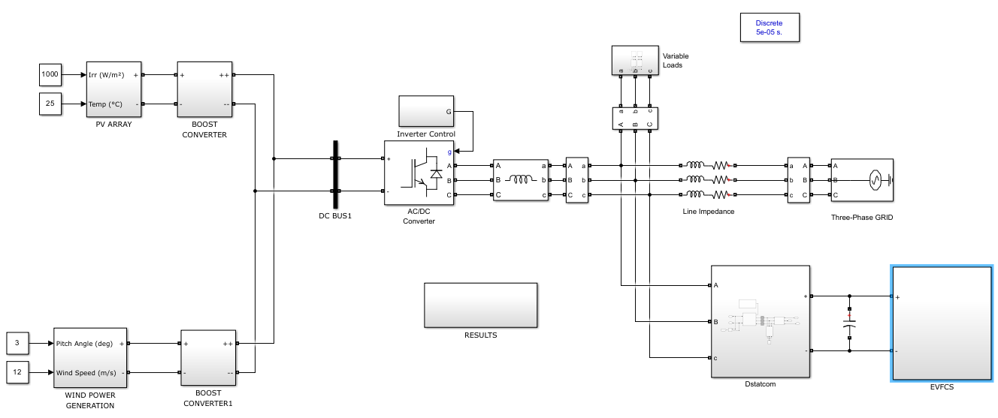
Block diagram
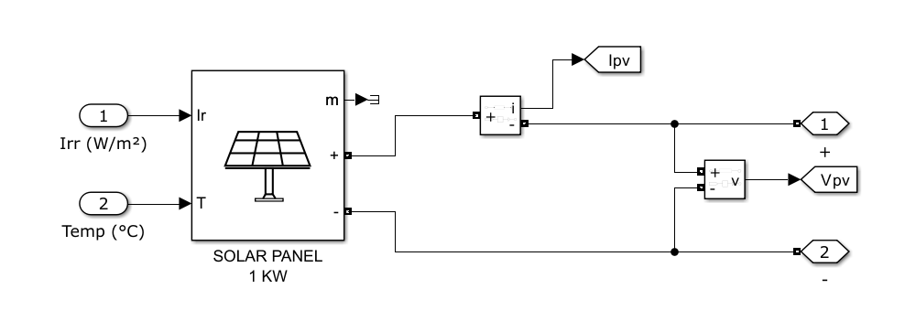
Solar side
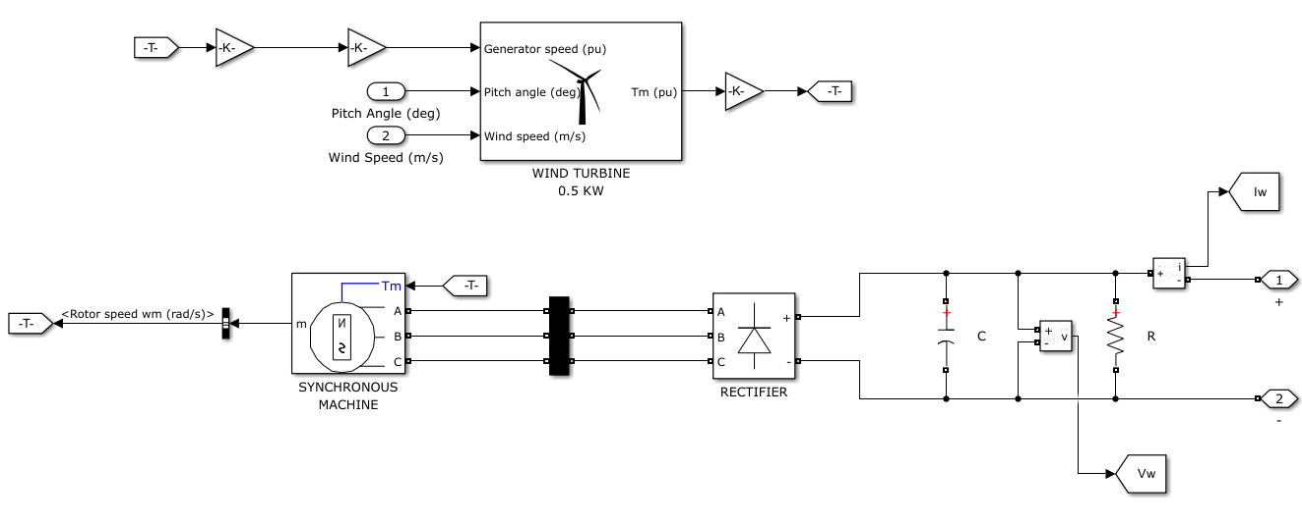
Wind side
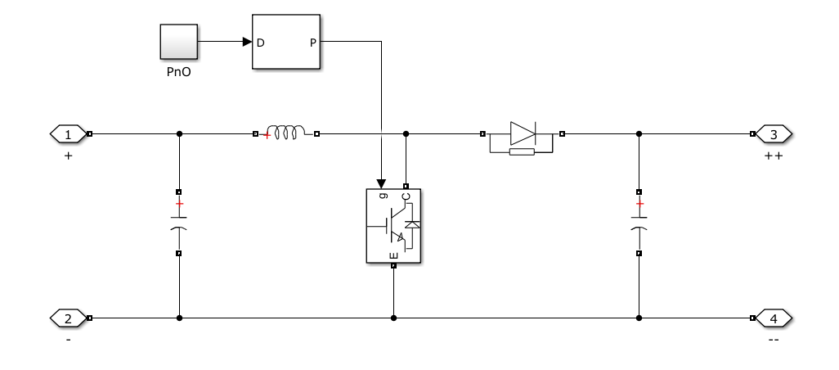
Boost converter (DC-DC)
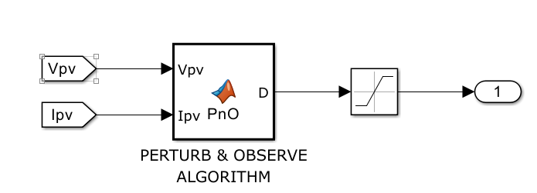
Solar and wind side Boost converter Controller
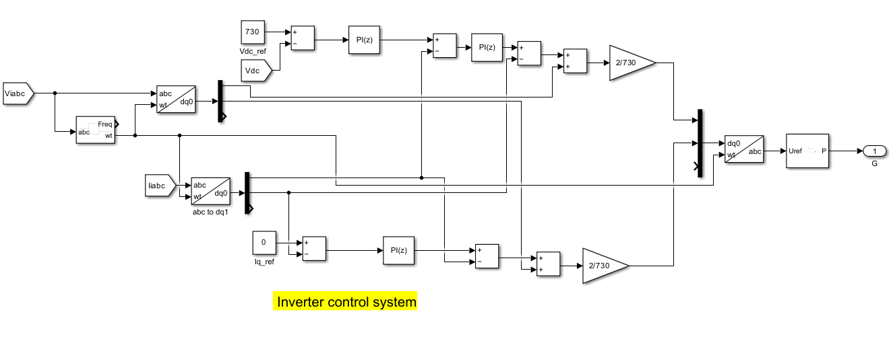
Dc-Ac inverter controller
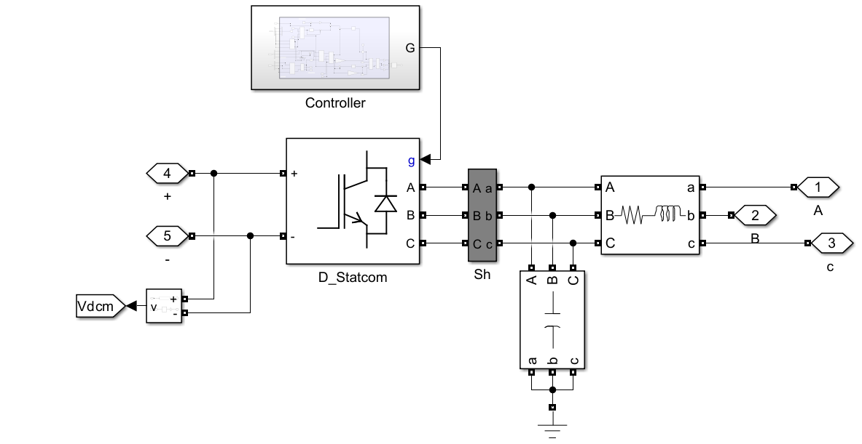
Dstatcom
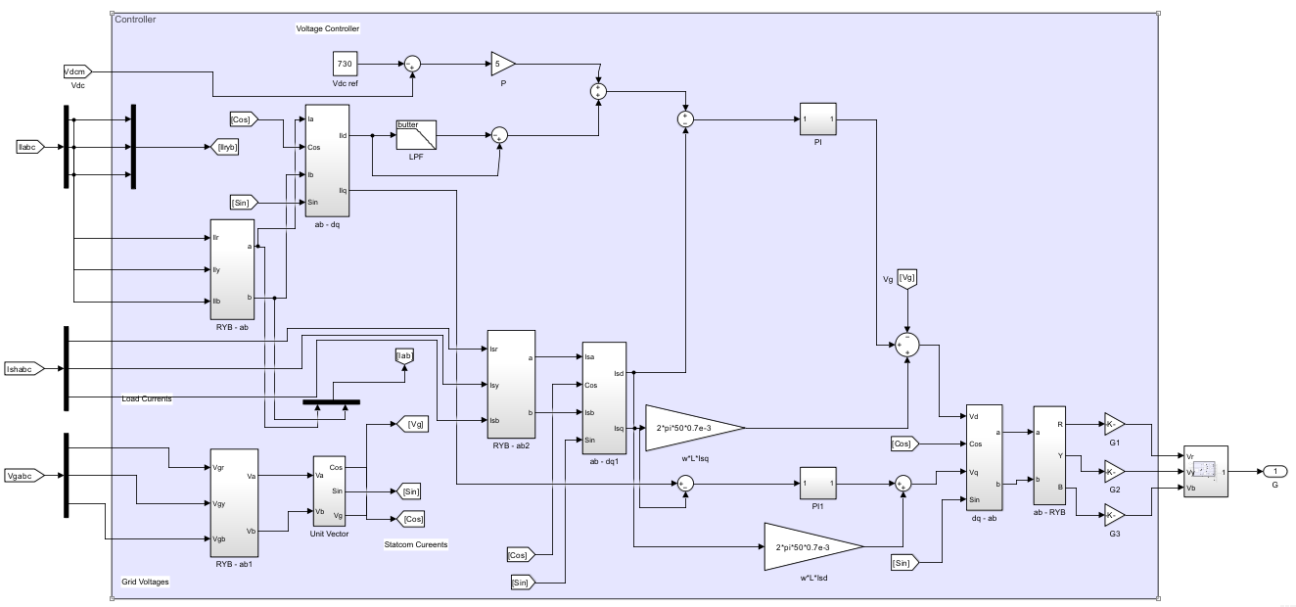
Dstatcom Controller
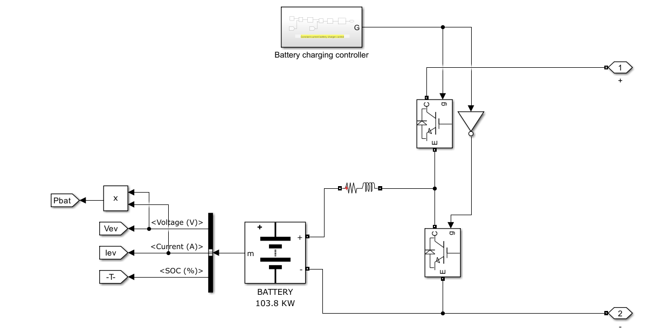
EV (Battery with Bidirectional converter (BDC))
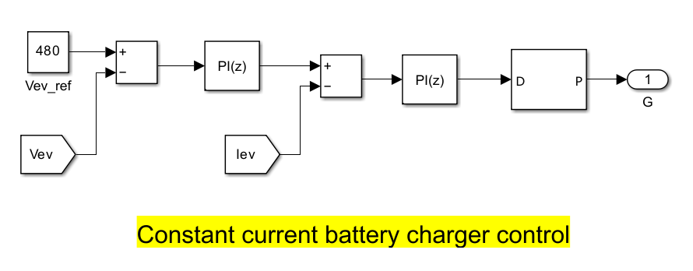
EV side Controller
Case: 1
Different charging modes (0.52 to 1 solar and wind disconnected case)
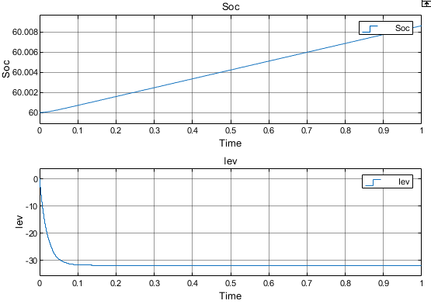
SOC & IEV
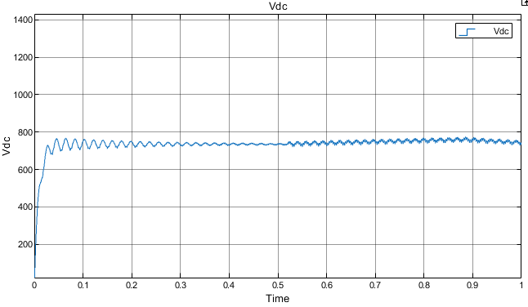
Vdc
Load variation:
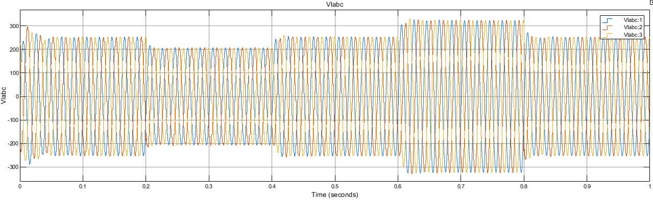
Vlabc
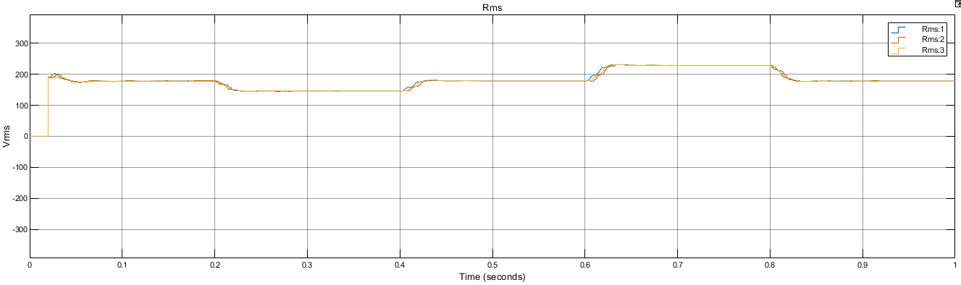
Vlrms
Dstatcom based results:
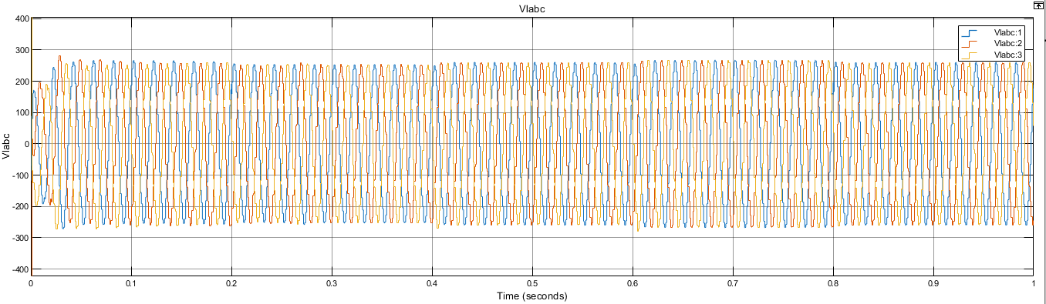
Vlabc
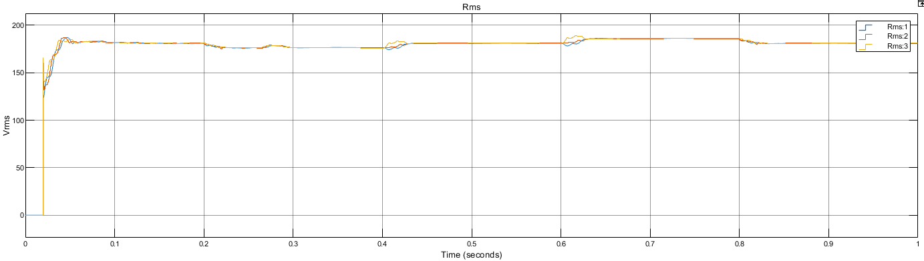
Vlrms
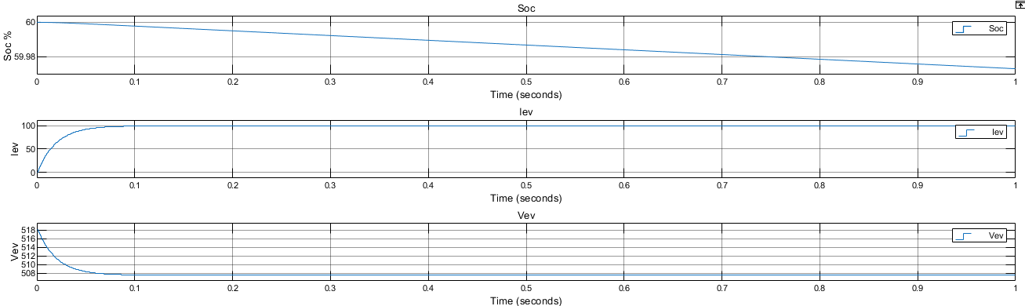
EV side Vev,

CONCLUSION
This study presents the idea of using a simplified model of decentralized PI control with renewable energy for fast charging modes in order to reduce grid reliance and make the system less polluted. The PI controllers are used to control the converters of two system components independently to achieve a coordinated operation. Besides, the idea of using an EV battery as a DC source for a D-STATCOM device to mitigate voltage sag/swell is considered in this paper. The STATCOM is built by integrating the PI control system and the implementation of the model in MATLAB/Simulink and SimPower Systems is described in detail. The results of the simulation studies conducted show that the proposed V2G system can be utilized to effectively overcome the power quality problems by reducing voltage sag and swell problems. As a future direction, the effectiveness of the proposed strategy is planned to be validated in a larger power grid including a higher number of components.

REFERENCES
- G. E. Outlook, “to Electric Mobility.” IEA: Paris, France (2019).
- M. Nour, H. Ramadan, A. Ali, and C. Farkas, “Impacts of plug-in electric vehicles charging on low voltage distribution network,” in 2018 International Conference on Innovative Trends in Computer Engineering (ITCE), 2018, pp. 357–362.
- X. Gong and J. Rangaraju, “Taking charge of electric vehicles both in the vehicle and on the grid,” Texas Instruments, Dallas, TX, USA, pp. 1–13, 2018.
  - K. Karmaker, S. Roy, and M. R. Ahmed, “Analysis of the impact of electric vehicle charging station on power quality issues,” in 2019 International Conference on Electrical, Computer and Communication Engineering (ECCE), 2019, pp. 1–6.
- P. García-Triviño, J. P. Torreglosa, L. M. Fernández-Ramírez, and F. Jurado, “Decentralized fuzzy logic control of microgrid for electric vehicle charging station,” IEEE J. Emerg. Sel. Top. Power Electron., vol. 6, no. 2, pp. 726–737, 2018.
- D. Wang, F. Locment, and M. Sechilariu, “Modelling, Simulation, and Management Strategy of an Electric Vehicle Charging Station Based on a DC Microgrid,” Appl. Sci., vol. 10, no. 6, p. 2053, 2020.
- L. Yang and H. Ribberink, “Investigation of the potential to improve DC fast charging station economics by integrating photovoltaic power generation and/or local battery energy storage system,” Energy, vol. 167, pp. 246–259, 2019.
- S. Wang, L. Lu, X. Han, M. Ouyang, and X. Feng, “Virtual-battery based droop control and energy storage system size optimization of a DC microgrid for electric vehicle fast charging station,” Appl. Energy, vol. 259, p. 114146, 2020.
- S. Wang, K. Kuang, X. Han, Z. Chu, L. Lu, and M. Ouyang, “A model-based continuous differentiable current charging approach for electric vehicles in direct current microgrids,” J. Power Sources, vol. 482, p. 229019, 2021.
- M. Dicorato, G. Forte, M. Trovato, C. B. Muñoz, and G. Coppola, “An integrated DC microgrid solution for electric vehicle fleet management,” IEEE Trans. Ind. Appl., vol. 55, no. 6, pp. 7347–7355, 2019.
- F. Ahmad, M. S. Alam, S. M. Shariff, and M. Krishnamurthy, “A cost-efficient approach to EV charging station integrated community microgrid: A case study of Indian power market,” IEEE Trans. Transp. Electrif., vol. 5, no. 1, pp. 200–214, 2019.
- B. Singh, A. Verma, A. Chandra, and K. Al Haddad, “Implementation of solar PV-battery and diesel generator based electric vehicle charging station,” IEEE Trans. Ind. Appl., 2020.
- Y. R. Rodrigues, A. C. Z. de Souza, and P. F. Ribeiro, “An inclusive methodology for Plug-in electrical vehicle operation with G2V and V2G in smart microgrid environments,” Int. J. Electr. Power Energy Syst., vol. 102, pp. 312–323, 2018.
- G. A. Salvatti, E. G. Carati, R. Cardoso, J. P. da Costa, and C. M. de O. Stein, “Electric vehicles energy management with V2G/G2V multifactor optimization of smart grids,” Energies, vol. 13, no. 5, p. 1191, 2020.
- O. Egbue and C. Uko, “Multi-agent approach to modeling and simulation of microgrid operation with vehicle-to-grid system,” Electr. J., vol. 33, no. 3, p. 106714, 2020.
- Q. Yang et al., “An improved vehicle to the grid method with battery longevity management in a microgrid application,” Energy, vol. 198, p. 117374, 2020.
- M. C. Falvo, L. Martirano, and D. Sbordone, “D-STATCOM with energy storage system for application in Smart Micro-Grids,” in 2013 International Conference on Clean Electrical Power (ICCEP), 2013.
- D. Leskarac, M. Moghimi, J. Liu, W. Water, J. Lu, and S. Stegen, “Hybrid AC/DC Microgrid testing facility for energy management in commercial buildings,” Energy Build., vol. 174, pp. 563–578, 2018.
  - M. Humada, M. Hojabri, S. Mekhilef, and H. M. Hamada, “Solar cell parameters extraction based on single and double-diode models: A review,” Renew. Sustain. Energy Rev., vol. 56, pp. 494–509, 2016.
- M. K. Siddiqui, M. A. Mallick, and A. Iqbal, “Performance analysis of closed loop control of diesel generator power supply for base transceiver (BTS) load,” 2019.
- F. M. Shakeel and O. P. Malik, “Vehicle-To-Grid Technology in a Micro-grid Using DC Fast Charging Architecture,” in 2019 IEEE Canadian Conference of Electrical and Computer Engineering (CCECE), 2019, pp. 1–4.
- P. García-Triviño, J. P. Torreglosa, L. M. Fernández-Ramírez, and F. Jurado, “Control and operation of power sources in a medium-voltage direct-current microgrid for an electric vehicle fast charging station with a photovoltaic and a battery energy storage system,” Energy, vol. 115, pp. 38–48, 2016.
- Y. Shan, J. Hu, K. W. Chan, Q. Fu, and J. M. Guerrero, “Model predictive control of bidirectional DC–DC converters and AC/DC interlinking converters—A new control method for PV-wind-battery microgrids,” IEEE Trans. Sustain. Energy, vol. 10, no. 4, pp. 1823–1833, 2018.
  - Arancibia and K. Strunz, “Modeling of an electric vehicle charging station for fast DC charging,” in 2012 IEEE International Electric Vehicle Conference, 2012, pp. 1–6.
- N. Koduri, S. Kumar, and R. Y. Udaykumar, “On-board Vehicle-to-Grid (V2G) integrator for power transaction in smart grid environment,” in 2014 IEEE International Conference on Computational Intelligence and Computing Research, 2014, pp. 1–4.
- S. A. Zulkifli, A. M. Mohammed, and F. Y. Tascikaraoglu, “Study Case: D-STATCOM in Low-Cost Hardware in the Loop for Voltage Sag Mitigation,” in 2021 IEEE International Conference in Power Engineering Application (ICPEA), 2021, pp. 30–34.

